

Faculty of Science, Alexandria University
Department of Computer Science

Studybuddy
Student Name:
Mohamed Walid Mohamed 20236555120
Bavly Adel Halim 20236539457
Yehia Badi Kodzo 20236535712
Mohamed Mokhtar Mohamed 20236555013
Mark Michel Bushra 20236556322

Supervisor: Dr. Ahmed Moustafa
Contents
Chapter 1 (Introduction) 6
1.1 Background 6
1.2 Motivation 7
1.3 Problem Statement 7
1.4 Importance of the Project 8
1.5 Goals 9
1.6 Currently Available Solutions (Applications) 10
1.7 Features Matrix 11
1.8 Agile Methodology 12
1.9 Why Agile Scrum Is the Best Choice 12
Chapter 2 (Requirements Analysis) 14
2.1 Questionnaire 14
2.1.1 Interview 1 — Ahmed (Age 21, Computer Science Student) 14
2.1.2 Interview 2 — Andrew (Age 22, Engineering Student) 15
2.1.3 Interview 3 — Mina (Age 23, Business Student) 15
2.1.4 Interview 4 —Mohamed (Age 22, Science Chemistry Student) 15
2.2 Survey Results, Charts, and Discussion 16
2.2.1 Student Survey 16
2.2.2 Instructor Survey 23
2.3 Discussion of Survey, Questionnaires, and Interviews Results 29
2.4 System Functional Requirements (FR) 30
2.4.1 Functional Requirements — User Management 30
2.4.2 Learning Content Management 31
2.4.3 AI-Based Learning Support 31
2.4.4 Instructor & Session Management 32
2.4.5 Courses & Bootcamps 32
2.4.6 Communication System 32
2.4.7 Ratings & Feedback 33
2.4.8 Study Groups 33
2.4.9 Instructor Marketplace 33
2.5 System Non-Functional Requirements 34
2.5.1 Performance 34
2.5.2 Reliability 34
2.5.3 Security 34
2.5.4 Usability 35
2.5.5 Scalability 35
2.5.6 Compatibility 35
2.5.7 Maintainability 36
2.5.8 Availability 36
2.6 Use Case Diagram 36
Chapter 3 (Design) 38
3.1 Sequence Diagrams 38
3.1.1 User Registration and Login 38
3.1.2 Search for an Instructor 38
3.1.3 Book a Learning Session 38
3.1.4 Upload PDF and Receive AI Explanation 39
3.1.5 Join a Study Group 39
3.1.6 Enroll in a Course or Bootcamp 39
3.1.7 AI-Based Instructor Recommendation 39
3.2 Entity Relationship Diagram 47
3.3 Data Flow Diagrams 50
3.3.1 DFD Level 0 (Context Diagram) 50
3.3.2 DFD Level 1 — Educational AI Platform 52
3.4 State Diagram 55
3.4.1 Authentication State 55
3.4.2 AI Teacher Matching State 55
3.4.3 Course Enrollment State 55
3.4.4 Course Content Management State 56
3.4.5 Assignment Submission State 56
3.4.6 Learning Progress Tracking State 57
3.4.7 Payment & Subscription State 57
Chapter 4 ( Implementation Aspect) 65
4.1 Overall System Architecture (Block Diagram) 65
4.2 Tools, Technologies and Programming Languages Used 68
4.3 Prototype 71
Figure 4.3.1: Login & Registration Page 71
Figure 4.3.2: Home Page 73
Figure 4.3.3: Add Material 74
Figure 4.3.4: Offer Page 75
Figure 4.3.5: Session 76
Figure 4.3.6: Bootcamp 77
Figure 4.3.7: bootcamp video 79
Figure 4.3.8: course 80
Figure 4.3.9: Instructor Profile Page 81
Figure 4.3.10: Students profile 82
Figure 4.3.11: Payment Page 83
Figure 4.3.12: Favorite 84
Figure 4.3.13: support 85
4.4 References 86
4.5 Conclusion 87
4.6 Future Work 88

Chapter 1 (Introduction)

1.1 Background
Online learning has become an important component of modern education, enabling students to access educational resources anytime and anywhere. The advancement of Artificial Intelligence has further enhanced educational technologies by providing personalized recommendations, intelligent tutoring systems, and automated learning support. However, many existing e-learning platforms still focus mainly on content delivery and lack comprehensive features that combine instructor matching, collaborative learning, and AI-powered academic assistance.
StudyBuddy is proposed as an intelligent university-focused learning platform that integrates AI technologies to connect students with suitable instructors, provide course-related resources, support collaborative study groups, and offer personalized learning recommendations. The platform aims to create a more effective and engaging learning environment for university students.

1.2 Motivation
The motivation behind StudyBuddy is to help university students overcome common learning challenges by providing an affordable, intelligent, and personalized educational platform. The project aims to connect students with qualified instructors, facilitate collaborative learning, and leverage Artificial Intelligence to deliver customized academic support that enhances learning outcomes and student success.

1.3 Problem Statement
Despite the rapid growth of online learning platforms, many existing solutions still fail to fully address the needs of university students. Most platforms primarily focus on providing educational content without offering personalized learning experiences that adapt to individual students’ academic levels, learning styles, and specific challenges.
University students often struggle to understand complex course materials and lecture content independently. In many cases, they require additional explanations and guidance beyond what is provided in traditional classroom settings. Furthermore, finding qualified instructors who match students’ academic needs and learning preferences can be a difficult and time-consuming process.
Another significant challenge is the limited use of intelligent technologies in many educational platforms. Existing systems rarely analyze learning materials, recommend suitable instructors, or provide personalized academic support based on students’ interests and performance. Additionally, communication and collaboration opportunities between students and instructors are often insufficient, reducing engagement and learning effectiveness.
Therefore, there is a need for an intelligent educational platform that leverages Artificial Intelligence to provide personalized learning support, facilitate student–teacher matching, encourage collaborative learning, and improve the overall academic experience of university students. The proposed StudyBuddy platform aims to address these challenges by creating a smart, accessible, and student-centered learning environment.

1.4 Importance of the Project
StudyBuddy is important because it helps university students access educational support in a simple and effective way. The platform connects students with suitable instructors based on their academic needs and interests. Using Artificial Intelligence, StudyBuddy provides personalized recommendations and helps students better understand their learning materials. This can improve academic performance and increase student engagement.
The platform also encourages collaborative learning through study groups, allowing students to learn and share knowledge with their peers. In addition, offering both individual and group learning options makes educational support more accessible and affordable. Overall, StudyBuddy creates a supportive learning environment that helps students achieve better academic results and enhances their learning experience.

1.5 Goals
- Develop an intelligent educational platform tailored to the needs of university students.
- Connect students with qualified instructors through smart recommendation mechanisms.
- Offer both individual and group learning sessions to provide flexible learning options.
- Provide specialized courses, bootcamps, and intensive training programs to support academic and professional development.
- Reduce educational costs by enabling collaborative group learning.
- Facilitate effective communication and interaction between students and instructors.
- Enable students and instructors to upload, share, and access educational documents and study materials.
- Create a platform that helps teaching assistants and instructors find teaching opportunities and reach students more easily.

1.6 Currently Available Solutions (Applications)
StudyBuddy is an educational platform specifically designed for university students. The platform aims to support students throughout their academic journey by providing personalized learning experiences, connecting them with qualified instructors, and offering courses, bootcamps, and training programs that help them develop practical skills and become better prepared for the job market. While several online learning and tutoring platforms are available today, most focus on limited aspects of education and do not provide a comprehensive solution that combines academic support, career-oriented learning, intelligent recommendations, collaborative study groups, and AI-powered educational assistance within a single platform.
Some of the most relevant existing solutions include:
- Studybay: A platform that connects students with academic experts and tutors for educational assistance.
- Studyloop: A learning platform that supports study material sharing and student collaboration.
- Preply: An online tutoring platform that helps students find instructors for one-on-one learning sessions.
Although these platforms provide valuable educational services, they lack several features that StudyBuddy aims to offer, such as AI-driven recommendations, collaborative study groups, smart learning assistance, and cost-effective shared learning sessions.

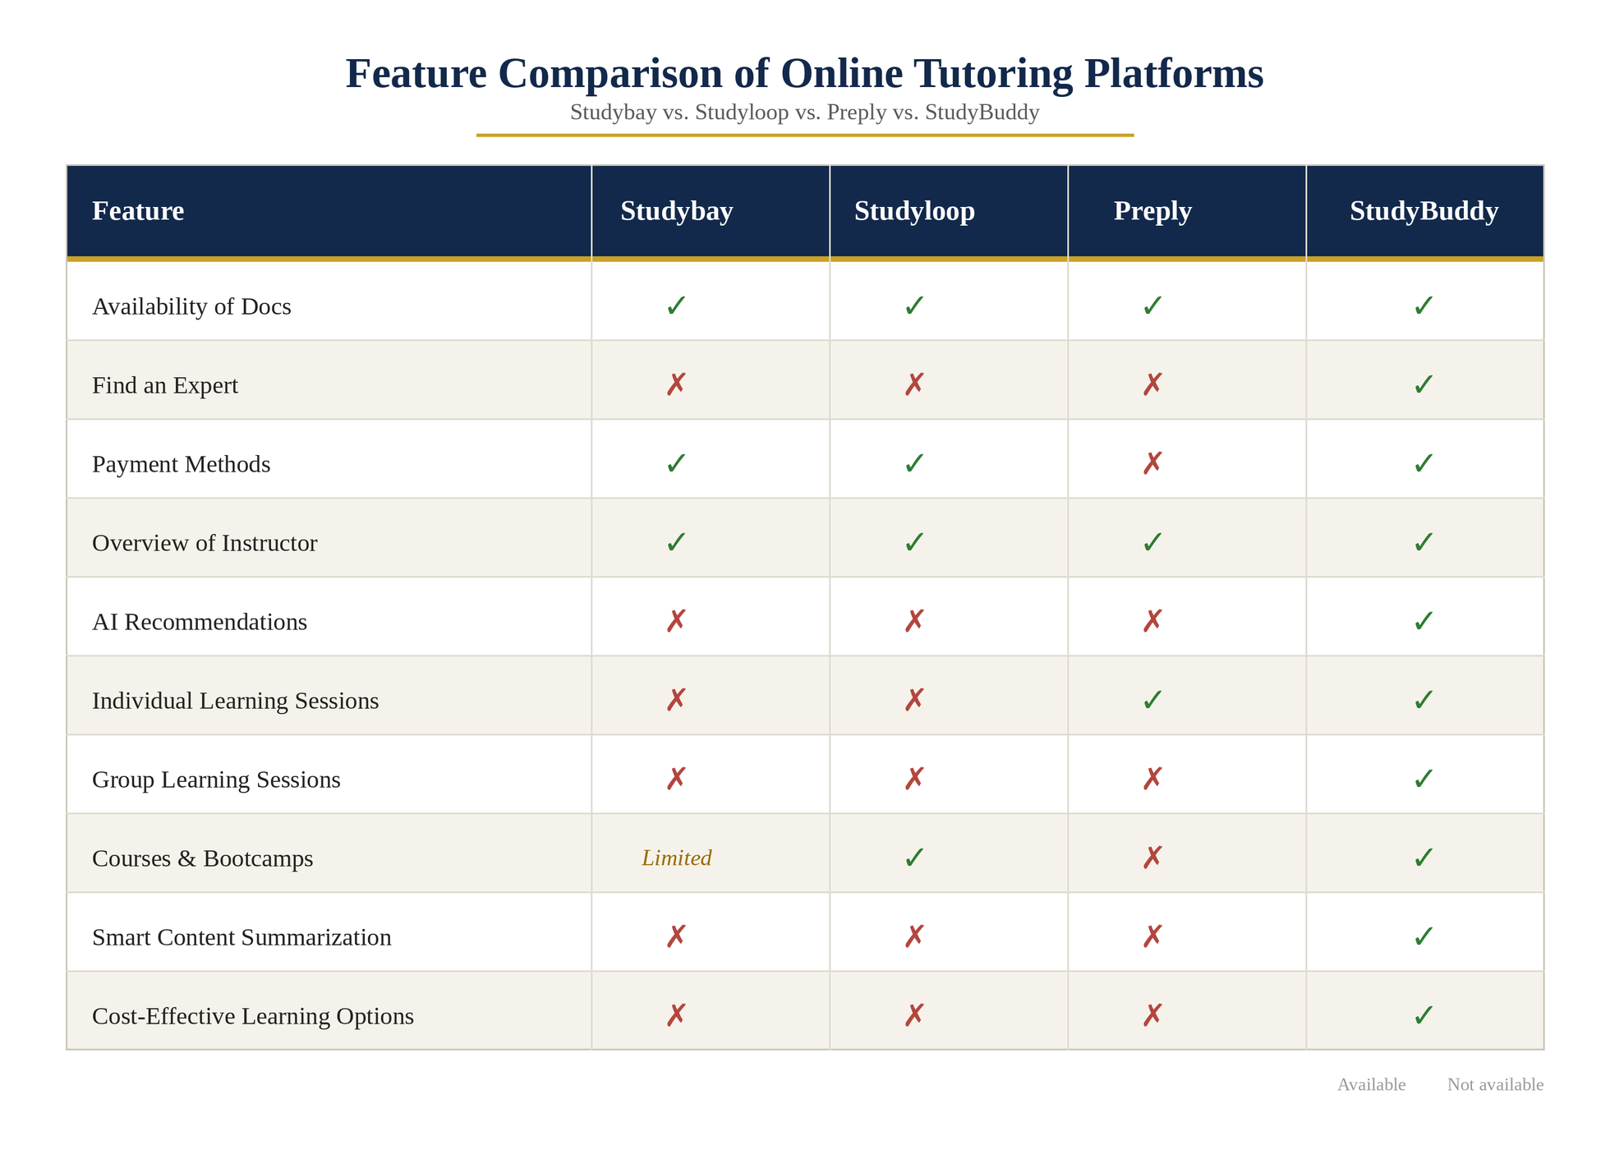
1.7 Features Matrix

1.8 Agile Methodology
Pros
- Highly flexible and adaptable to changing requirements.
- Supports continuous improvement throughout development.
- Encourages frequent user and stakeholder feedback.
- Enables incremental delivery of working features.
- Suitable for AI-based and feature-rich systems.
Cons
- Requires continuous communication among team members.
- Depends on active stakeholder involvement.
- Requires careful sprint planning and management.

1.9 Why Agile Scrum Is the Best Choice
1. StudyBuddy Includes:
StudyBuddy includes AI-powered instructor recommendations, personalized learning support, study groups, course management, document sharing, communication tools, and specialized training programs.
2. These Characteristics Strongly Require:
These features require continuous improvement, regular testing, user feedback, and incremental feature delivery. Agile Scrum provides an effective framework for managing such requirements.

3. Requirement Complexity:
The system contains multiple functional modules including user authentication, student and instructor profiles, AI recommendations, course management, study groups, educational resource sharing, and communication features. Scrum allows these modules to be prioritized and developed incrementally.
4. Incremental Delivery:
Sprint | Features
Sprint 1 | User Registration, Login, Profile Management
Sprint 2 | Instructor Profiles and Search
Sprint 3 | AI-Based Instructor Recommendation
Sprint 4 | Study Groups and Collaboration
Sprint 5 | Course and Bootcamp Management
Sprint 6 | Document Sharing and Resource Management
Sprint 7 | Messaging, Notifications, and System Enhancement
5. Adaptability to Change:
Features such as AI recommendations, learning personalization, and instructor matching algorithms may require continuous refinement. Agile Scrum allows the team to improve these features based on testing results and user feedback.

Chapter 2 (Requirements Analysis)

2.1 Questionnaire
- What is your main goal in using an online learning platform? (e.g., understanding lectures, finding instructors, improving grades, collaborative learning)
- How do you currently study or understand difficult course materials? (e.g., self-study, YouTube, private tutoring, study groups)
- Have you ever used any e-learning platforms before? What problems did you face while using them?
- What is the biggest challenge you face during your academic studies? (e.g., difficulty understanding content, lack of guidance, lack of time, cost of tutoring)
- How useful would it be to have a platform that connects you with qualified instructors and study groups based on your needs?
- Which features would you consider most important in a learning platform? (e.g., AI recommendations, document sharing, study groups, live sessions, progress tracking)

2.1.1 Interview 1 — Ahmed (Age 21, Computer Science Student)
Ahmed struggles with understanding complex programming and mathematics courses. He usually depends on YouTube videos and notes from friends. He has tried online learning platforms before but found them too general and not tailored to his academic level. His main challenge is finding clear explanations and qualified instructors who can simplify difficult topics.

2.1.2 Interview 2 — Andrew (Age 22, Engineering Student)
Andrew often finds it difficult to understand theoretical subjects and prefers visual explanations. She has used online courses but stopped because they were not interactive enough. Her biggest challenge is the lack of personalized guidance and feedback. She would benefit from a system that recommends suitable instructors and provides study groups for collaborative learning.

2.1.3 Interview 3 — Mina (Age 23, Business Student)
Mina struggles with time management and exam preparation. He often studies alone and finds it hard to stay consistent. He has tried e-learning platforms but felt they were not organized according to his academic needs. He believes that structured study plans and AI-based recommendations would help him stay on track.

2.1.4 Interview 4 —Mohamed (Age 22, Science Chemistry Student)
Mohamed deals with heavy academic content and requires continuous support to understand complex subjects. He uses multiple sources for studying, which is time-consuming. His main challenge is the lack of a unified platform that combines instructors,study materials, and peer support. He would prefer a platform that organizes learning resources and connects him with experts in his field.

2.2 Survey Results, Charts, and Discussion

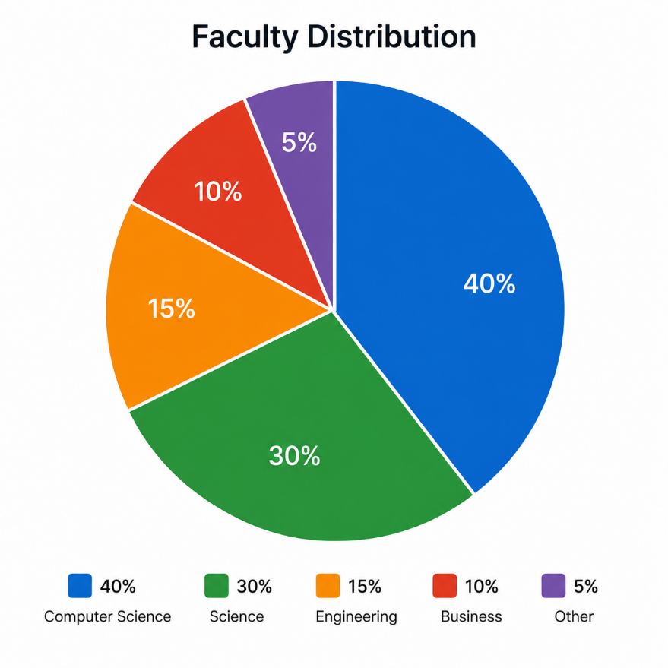
2.2.1 Student Survey
Figure 1.1: What is your faculty?
Computer Science represented the largest group of respondents (40%) , followed by Science (30%), Engineering (15%), Business (10%), and Other (5%). This indicates strong participation from technology-related faculties.

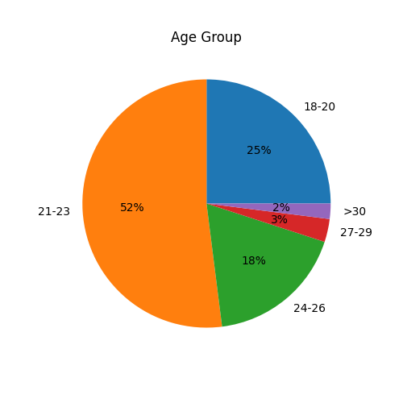
Figure 1.2: What is your age group?
The majority of respondents are aged 21–23 years (52%), followed by 18–20 years (25%) and 24–26 years (18%). Only a small percentage belong to the 27–29 years (3%) and above 30 years (2%) age groups, as shown in Figure 1.2.

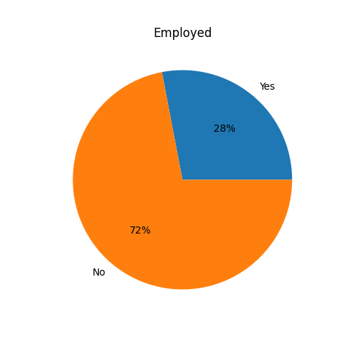
Figure 1.3: Are you currently employed?
Most respondents are not currently employed (72%), while 28% reported being employed, as shown in Figure 1.3.

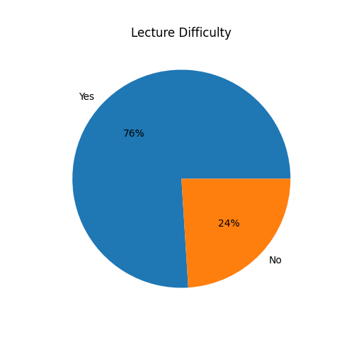
Figure 1.4: Do you face difficulties understanding lectures?
A significant majority of respondents (76%) reported facing difficulties understanding lectures, while only 24% indicated that they do not experience such difficulties, as shown in Figure 1.4.

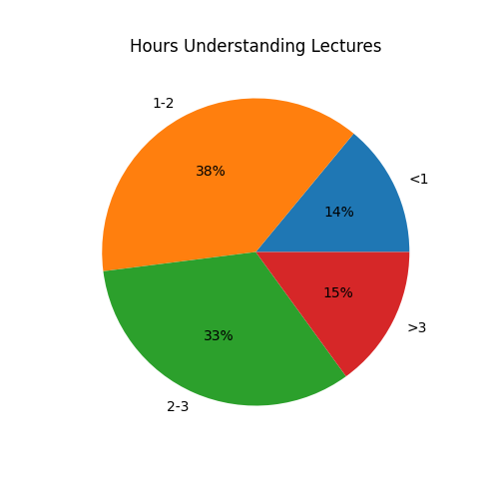
Figure 1.5: On average, how many hours do you spend daily trying to understand lectures?
Most respondents spend between 1–2 hours daily trying to understand lectures (38%), followed by 2–3 hours (33%). Smaller percentages spend less than 1 hour (14%) or more than 3 hours (15%), as shown in Figure 1.5.

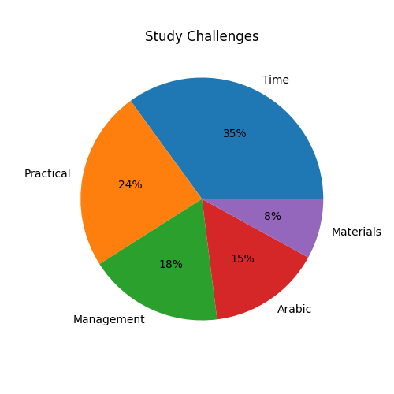
Figure 1.6: What is the biggest challenge in your studies?
The biggest challenge reported by respondents is spending too much time understanding lectures (35%), followed by lack of practical applications (24%) and poor time management (18%). Other challenges include lack of Arabic educational content (15%) and incomplete learning materials (8%), as shown in Figure 1.6.

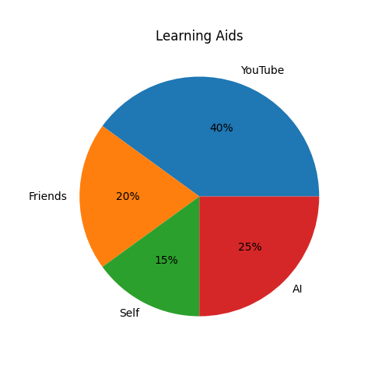
Figure 1.7: What helps you understand lectures better?
YouTube videos are the most preferred learning aid among respondents (40%), followed by AI tools such as ChatGPT and Gemini (25%). Friends or classmates account for 20%, while lecture materials and self-study represent 15%, as shown in Figure 1.7.

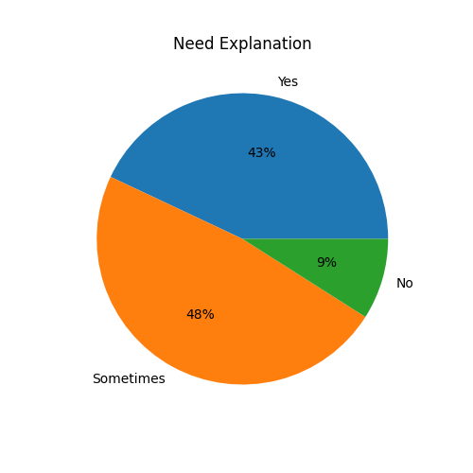
Figure 1.8: Do you usually need someone to explain lectures to you?
Nearly half of the respondents (48%) sometimes need someone to explain lectures, while 43% consistently require explanations. Only 9% reported that they do not need additional explanations, as shown in Figure 1.8.

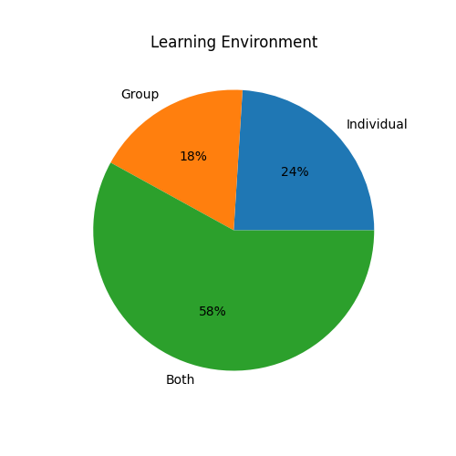
Figure 1.10: In which learning environment do you understand better?
Most respondents (58%) indicated that they learn equally well in both individual and group settings. Meanwhile, 24% prefer individual learning and 18% prefer group learning, as shown in Figure 1.10.

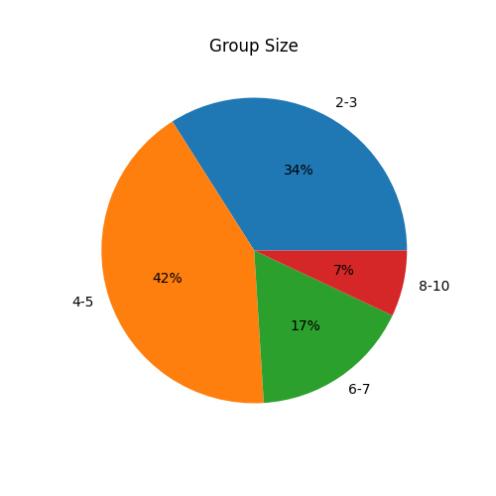
Figure 1.11: How many students would you be comfortable studying with in a group session?
The preferred group size among respondents is 4–5 students (42%), followed by 2–3 students (34%). Fewer respondents prefer groups of 6–7 students (17%) or 8–10 students (7%), as shown in Figure 1.11.

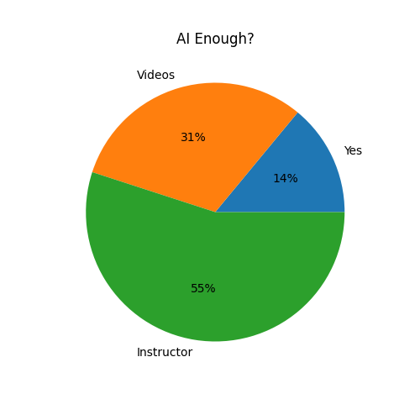
Figure 1.12: Is AI alone enough to help you fully understand your courses?
More than half of the respondents (55%) believe they still need someone to explain and discuss course materials with them. Additionally, 31% still require educational videos, while only 14% consider AI alone sufficient, as shown in Figure 1.12.

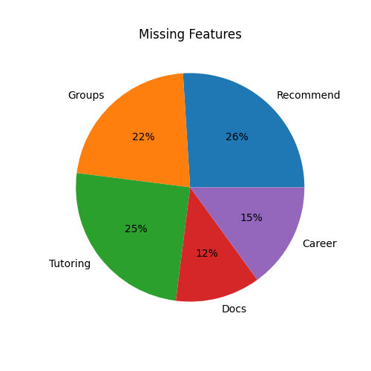
Figure 1.13: What features are missing in current educational platforms?
Respondents identified personalized recommendations (26%) and low-cost tutoring (25%) as the most needed features. Study groups account for 22%, while career-focused training (15%) and academic document sharing (12%) were also highlighted, as shown in Figure 1.13.

Figure 1.14: Would you be interested in uploading lecture PDFs and receiving AI-generated explanations and instructor recommendations?
A large majority of respondents (79%) expressed interest in uploading lecture PDFs to receive AI-generated explanations and instructor recommendations. Meanwhile, 16% were uncertain, and only 5% were not interested, as shown in Figure 1.14.

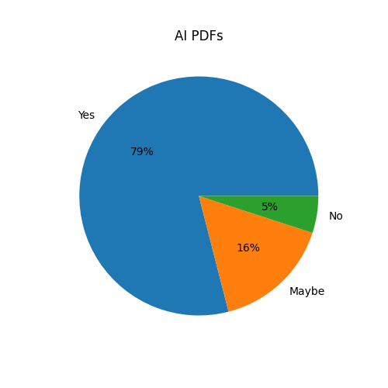

2.2.2 Instructor Survey
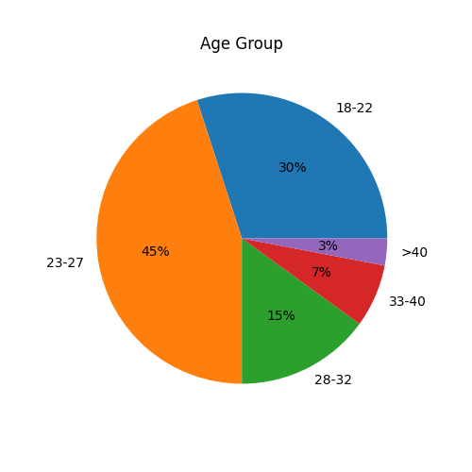
Figure 1.1: What is your age group?
Age distribution shows that 45% of respondents are aged 23–27 years, followed by 30% in the 18–22 years category, 15% in the 28–32 years category, 7% in the 33–40 years category, and 3% above 40 years, as shown in Figure 1.1.

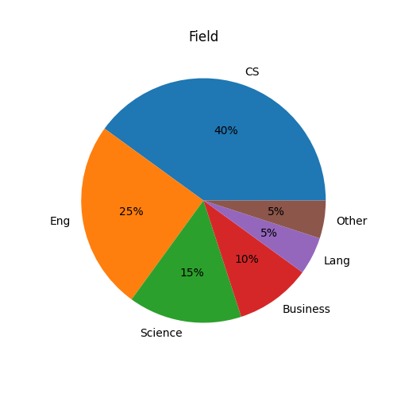
Figure 1.2: What is your current role?
The majority of respondents are Teaching Assistants (40%) and Private Tutors (30%), followed by University Professors (15%), Industry Experts (10%), and Student Instructors (5%), as shown in Figure 1.2.


Figure 1.3: Which field do you teach?
Computer Science represents the largest teaching field among respondents (40%), followed by Engineering (25%), Science (15%), Business (10%), Languages (5%), an d Other fields (5%), as shown in Figure 1.3.

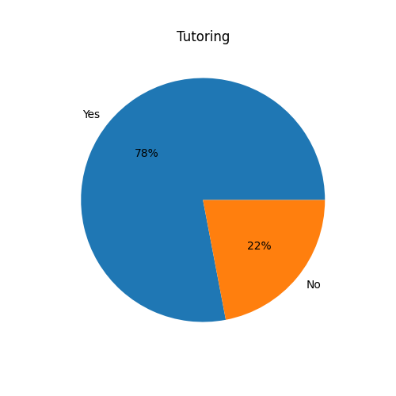
Figure 1.4: Do you currently provide private tutoring or educational sessions?
Most respondents (78%) currently provide tutoring or educational sessions, while 22% do not, as shown in Figure 1.4.

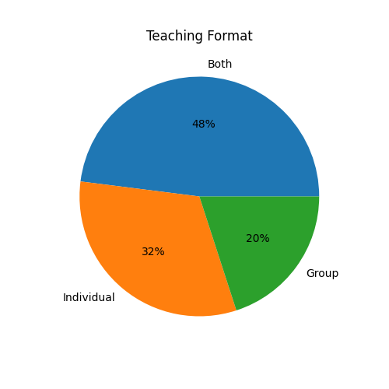
Figure 1.5: What teaching format do you currently prefer?
Teaching preferences show that 48% of instructors prefer both individual and group sessions, while 32% prefer individual sessions and 20% prefer group sessions, as shown in Figure 1.5.

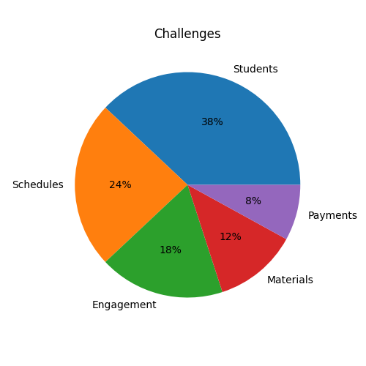
Figure 1.6: What challenges do you face as an instructor?
The most common challenge reported by instructors is finding students (38%), followed by managing schedules (24%), student engagement (18%), sharing learning materials (12%), and payment management (8%), as shown in Figure 1.6.

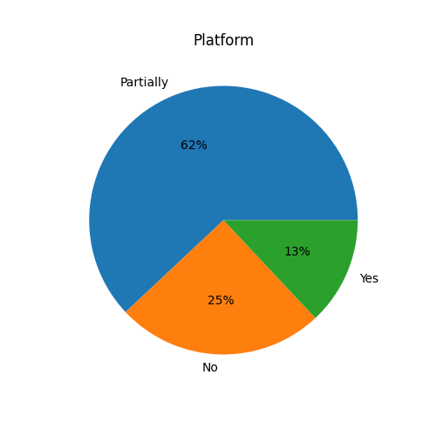
Figure 1.7: Is there currently an educational platform that effectively connects university students with instructors?
Most respondents (62%) believe that current platforms only partially meet this need, while 25% believe no such platform exists and 13% believe that existing platforms are sufficient, as shown in Figure 1.7.

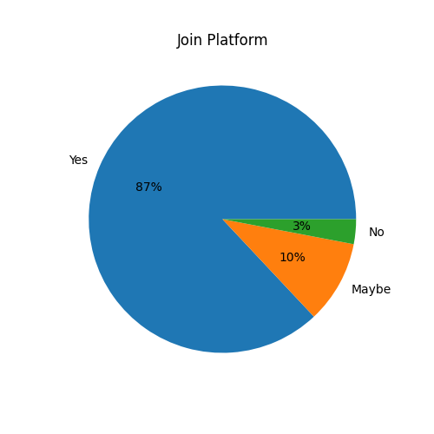
Figure 1.8: Would you be interested in a platform that connects you with students seeking academic support?
An overwhelming majority of respondents (87%) expressed interest in joining a platform that connects instructors with university students, while 10% were uncertain and only 3% were not interested, as shown in Figure 1.8.
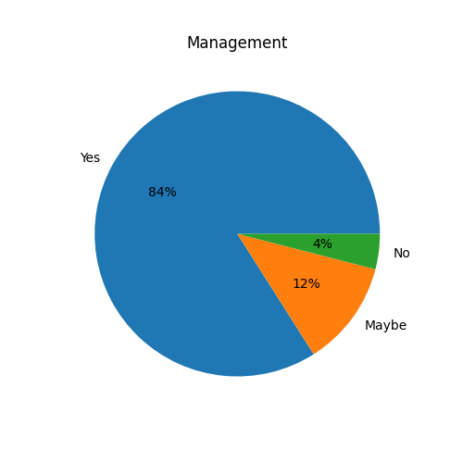
Figure 1.9: Would you use a platform that helps you manage sessions, payments, and educational materials?
Most respondents (84%) indicated that they would use an integrated platform for managing educational activities, while 12% answered "Maybe" and only 4% answered "No", as shown in Figure 1.9.

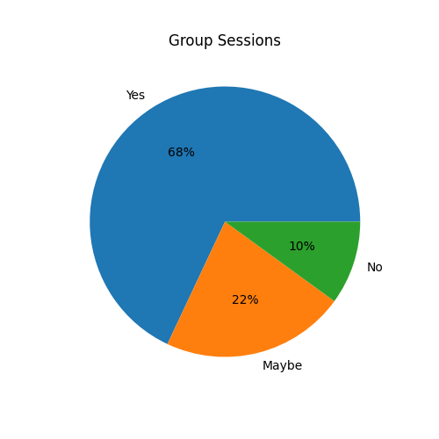
Figure 1.10: Are you willing to offer group sessions at a lower cost to attract more students?
A majority of respondents (68%) expressed willingness to offer group sessions at lower costs, while 22% selected "Maybe" and 10% selected "No", as shown in Figure 1.10.

Figure 1.11: Would AI-powered recommendations help match you with suitable students?
Most instructors (81%) believe that AI-powered recommendations would help them reach suitable students, while 14% were uncertain and only 5% disagreed, as shown in Figure 1.11.
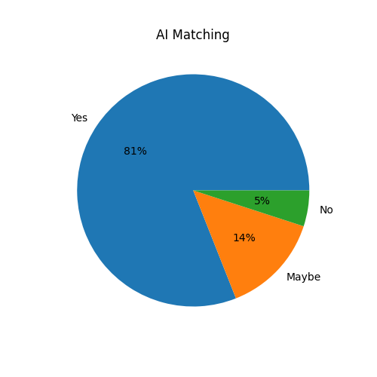

2.3 Discussion of Survey, Questionnaires, and Interviews Results
The survey results indicate that most participants are university students between the ages of 18 and 23, with a large proportion coming from Computer Science and Engineering faculties. This reflects the growing interest of students in technology-based educational solutions and digital learning platforms.
A significant majority of respondents reported facing difficulties in understanding lecture materials and often spend additional time outside class trying to comprehend course content. This highlights the need for accessible educational support and personalized learning resources beyond traditional university lectures.
The findings also revealed that students frequently rely on YouTube videos, classmates, and AI tools such as ChatGPT and Gemini to better understand their courses. However, many respondents indicated that AI tools alone are not sufficient and that they still require direct interaction with instructors or peers to achieve a deeper understanding of complex topics.
Regarding learning preferences, most participants preferred a combination of both individual and group learning environments. Furthermore, many students expressed interest in studying in small groups, particularly groups consisting of four to five students. These results support the inclusion of both individual and group learning sessions within the StudyBuddy platform.
The survey additionally showed strong demand for features such as personalized recommendations, low-cost tutoring, study groups, academic document sharing, and career-oriented courses and bootcamps. Students also demonstrated high interest in uploading lecture PDFs and receiving AI-generated explanations and instructor recommendations, emphasizing the importance of integrating Artificial Intelligence into the learning process.
Moreover, many instructors reported challenges in finding students, managing schedules, and organizing educational materials. They also expressed interest in a platform that connects them with university students and provides additional teaching opportunities. This validates StudyBuddy’s role as a marketplace that benefits both students and instructors.
Overall, the survey and interview results confirm the need for a comprehensive educational platform that combines AI-powered learning assistance, instructor matching, collaborative study groups, and career-focused training programs. These findings strongly support StudyBuddy’s design decisions and functional requirements, ensuring that the platform addresses the real needs of both students and educators.

2.4 System Functional Requirements (FR)
The system functional requirements describe the specific behaviors, features, and operations that the StudyBuddy platform must support.

2.4.1 Functional Requirements — User Management
- FR-1 Create user accounts using email and password.
- FR-2 Verify user registration via email code.
- FR-3 Support secure login and logout functionality.
- FR-4 Reset passwords using email verification.
- FR-5 Create and edit personal profiles (name, university, faculty, academic level).
- FR-6 Update personal profile information when needed.
- FR-7 Require users to accept terms and privacy policy during registration.
- FR-8 Allow users to export their personal data.
- FR-9 Delete accounts and permanently erase user data from the system.

2.4.2 Learning Content Management
- FR-10 Allow students to upload lecture PDF files.
- FR-11 Allow instructors to upload educational materials.
- FR-12 Organize uploaded materials by subject or course.
- FR-13 Enable viewing and accessing uploaded study content.

2.4.3 AI-Based Learning Support
- FR-14 Provide AI-based explanation of uploaded lecture content.
- FR-15 Generate summaries of educational materials.
- FR-16 Recommend suitable instructors based on student needs.
- FR-17 Suggest relevant courses based on academic interest.

2.4.4 Instructor & Session Management
- FR-18 Allow instructors to create teaching profiles.
- FR-19 Enable students to search for instructors.
- FR-20 Support booking individual learning sessions.
- FR-21 Support group learning sessions with instructors.
- FR-22 Manage session scheduling and availability.

2.4.5 Courses & Bootcamps
- FR-23 Allow instructors to create courses.
- FR-24 Allow instructors to create bootcamps (intensive learning programs).
- FR-25 Enable students to enroll in courses and bootcamps.
- FR-26 Support collaborative learning through bootcamps.
- FR-27 Reduce learning cost through shared group sessions.

2.4.6 Communication System
- FR-28 Provide chat system between students and instructors.
- FR-29 Allow real-time communication for academic support.
- FR-30 Send notifications for sessions and updates.

2.4.7 Ratings & Feedback
- FR-31 Allow students to rate instructors.
- FR-32 Allow students to write reviews and feedback.
- FR-33 Display instructor ratings for other students.

2.4.8 Study Groups
- FR-34 Allow students to create study groups.
- FR-35 Allow students to join existing groups.
- FR-36 Enable instructors to participate in study groups.

2.4.9 Instructor Marketplace
- FR-37 Allow instructors to offer their teaching services.
- FR-38 Allow students to browse available instructors.
- FR-39 Enable booking of instructors directly through the platform.
- FR-40 Support bootcamps as cost-effective learning options.

2.5 System Non-Functional Requirements
Non-functional requirements describe how the StudyBuddy system should operate in terms of quality attributes such as performance, security, usability, reliability, and scalability.

2.5.1 Performance
The system should provide fast response times across all features. Pages and interfaces should load quickly, and actions such as uploading files, searching instructors, and accessing materials should respond within a few seconds. AI-based operations such as explanations and recommendations should also be processed efficiently.

2.5.2 Reliability
The system should ensure stable operation with minimal downtime. User data must be saved immediately to prevent loss, and system processes should continue smoothly even during temporary connection issues. The platform should recover safely after unexpected interruptions.

2.5.3 Security
The system should protect user data through secure authentication and encrypted communication. Access to personal information, files, and learning data should be restricted based on user roles. The system should also prevent unauthorized access and protect against repeated failed login attempts.

2.5.4 Usability
The system should have a simple and user-friendly interface that is easy to understand and navigate. Features such as uploading files, booking sessions, and accessing AI tools should be accessible without complexity, ensuring a smooth learning experience for all users.

2.5.5 Scalability
The system should be able to handle an increasing number of users, instructors, and learning materials without performance degradation. It should also support future expansion such as adding new features, courses, and AI services.

2.5.6 Compatibility
The system should be accessible through different devices and screen sizes, including desktops, tablets, and mobile phones. It should work on modern web browsers without compatibility issues.

2.5.7 Maintainability
The system should be designed in a modular way to allow easy updates and maintenance. New features can be added without affecting existing functionality, and the codebase should be organized and well documented.

2.5.8 Availability
The system should be available most of the time with minimal downtime. It should allow users to continue using core features even with weak internet connectivity and recover previous sessions when the connection is restored.

2.6 Use Case Diagram
The Use Case Diagram illustrates the main interactions between users and the StudyBuddy platform. It provides a high-level overview of the system’s functional behavior by identifying the actors involved and the services offered by the system.The diagram focuses on how students and instructors interact with the core features of the platform, such as user management, uploading and accessing learning materials, AI-based learning support, booking and managing sessions, study groups, courses and bootcamps, communication, and ratings. This diagram helps in understanding the system scope, defining user roles and responsibilities, and clarifying the relationship between different functionalities. It serves as an effective tool for communicating system requirements and ensuring that both functional and non-functional requirements are properly addressed during the design and implementation phases of the project, as shown in Figure 4.1.
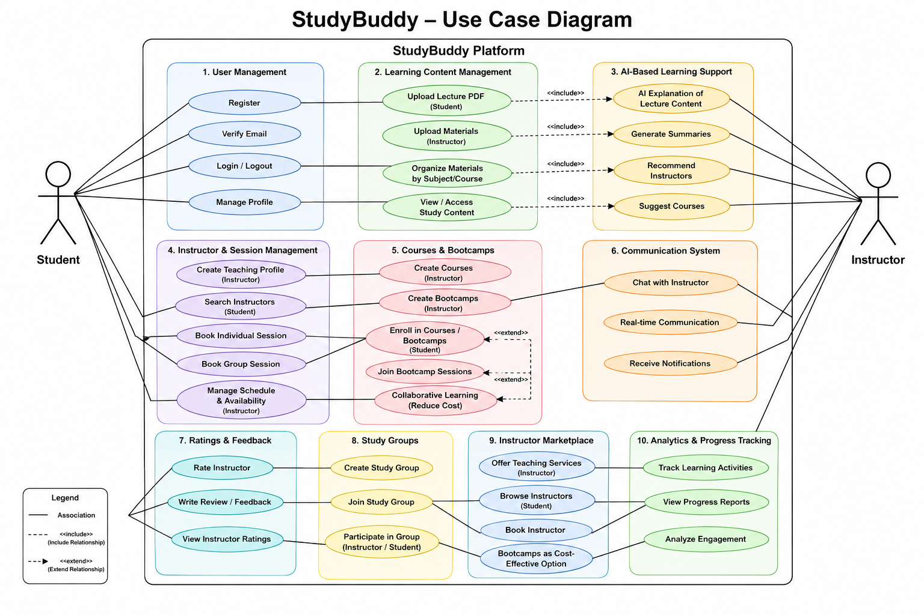

Chapter 3 (Design)

3.1 Sequence Diagrams

3.1.1 User Registration and Login
This sequence diagram illustrates the process of student or instructor account creation, email verification, secure login, and authentication validation between the user, the StudyBuddy platform, and the database system. It ensures secure access control and proper user identity management, as shown in Figure 3.1.1.

3.1.2 Search for an Instructor
This diagram represents how students search for instructors based on course name, specialization, or academic field. The system retrieves matching instructors from the database and displays the results to help students find suitable educational support, as shown in Figure 3.1.2.

3.1.3 Book a Learning Session
This sequence shows how a student selects and books an individual or group learning session. The system verifies instructor availability, stores the booking information, and sends notifications to both parties. It ensures an organized and efficient booking process, as shown in Figure 3.1.3

3.1.4 Upload PDF and Receive AI Explanation
This diagram demonstrates how students upload lecture materials or PDF documents to the platform. The AI module analyzes the content and generates explanations or summaries to help students better understand the uploaded materials. This feature enhances personalized learning and academic support, as shown in Figure 3.1.4

3.1.5 Join a Study Group
This sequence illustrates how students browse available study groups, request to join a group, and become members after verification. The process encourages collaborative learning and knowledge sharing among students, as shown in Figure 3.1.5

3.1.6 Enroll in a Course or Bootcamp
This diagram models how students browse available courses and bootcamps, complete the enrollment process, and gain access to educational content. It supports both academic and career-oriented learning opportunities, as shown in Figure 3.1.6.

3.1.7 AI-Based Instructor Recommendation
This sequence diagram shows how the system analyzes student preferences, uploaded materials, and academic needs to recommend the most suitable instructors. The AI recommendation engine improves the matching process and helps students find qualified educators more efficiently, as shown in Figure 3.1.7.

Figure 3.1.1
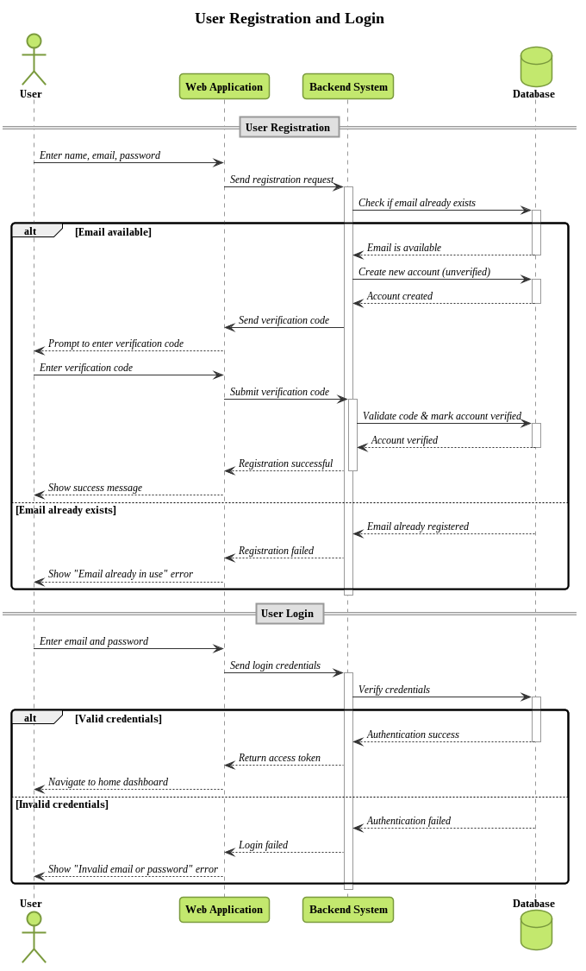

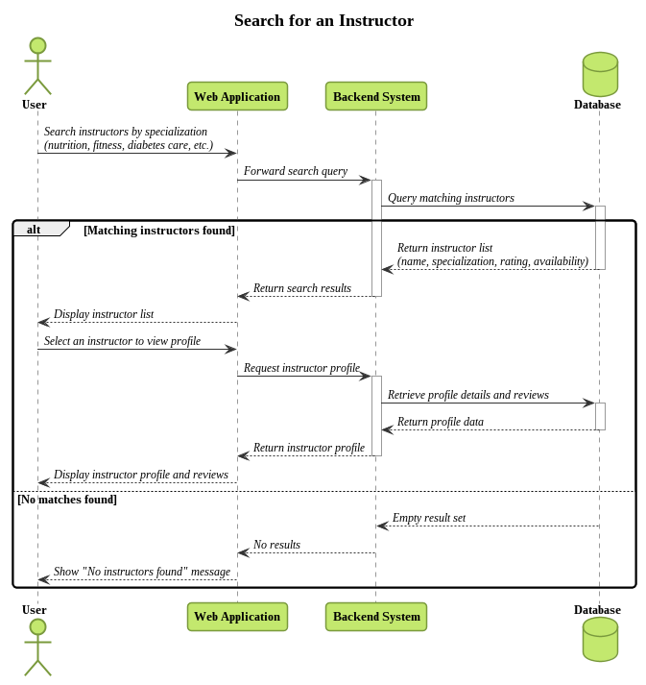
Figure 3.1.2
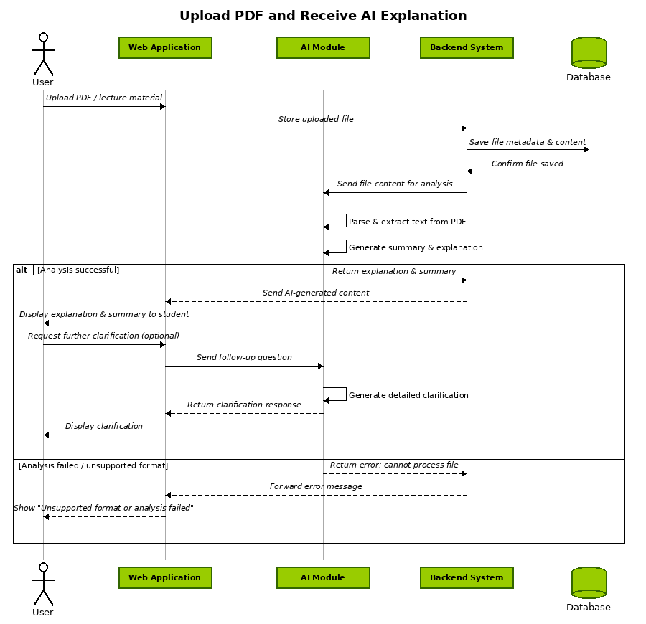
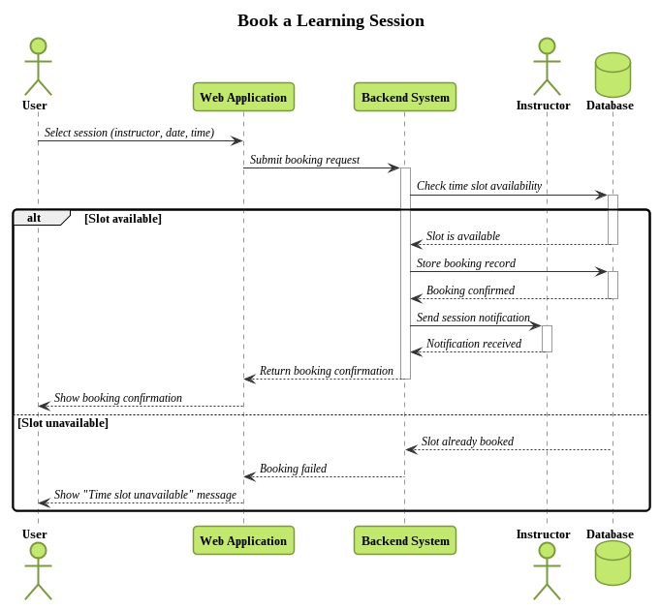
Figure 3.1.3
Figure 3.1.4


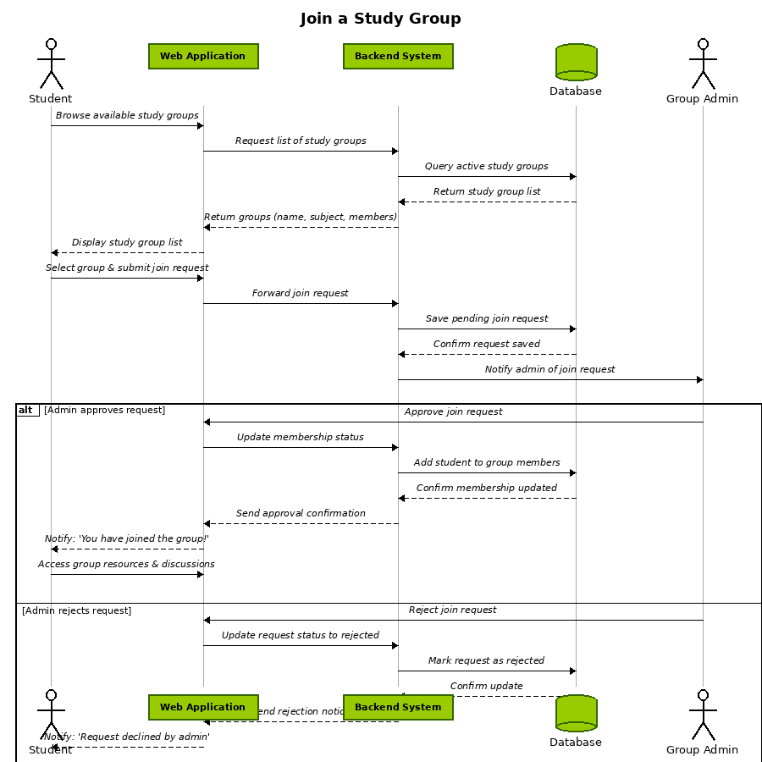
Figure 3.1.5

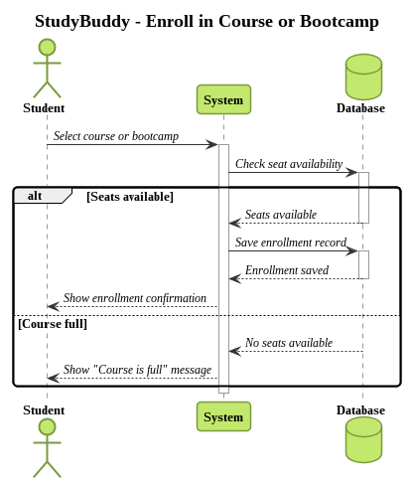
Figure 3.1.6
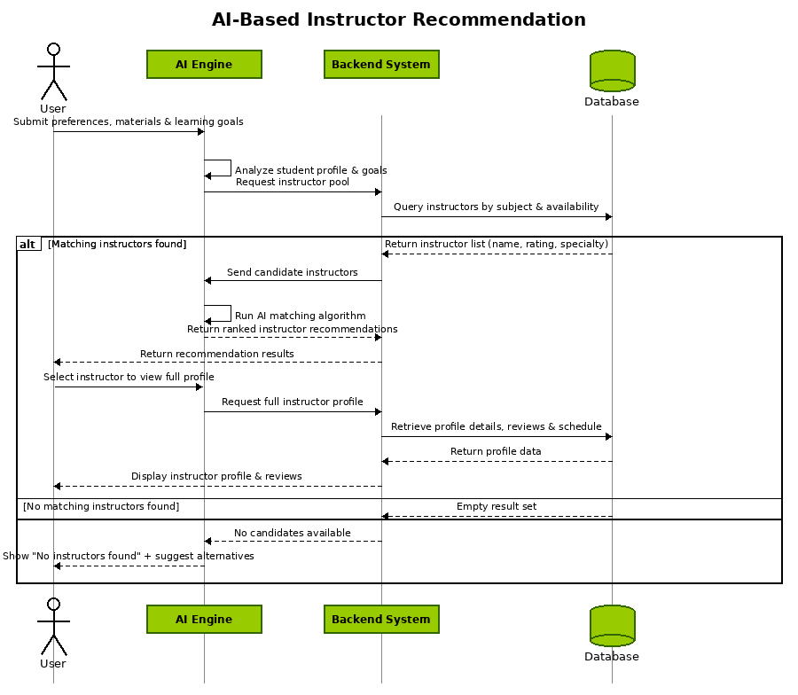
Figure 3.1.7

3.2 Entity Relationship Diagram
The system ERD is centered around the User entity, which represents all platform participants including students, teachers, and administrators. The User entity connects to specialized profile entities such as Student_Profile and Teacher_Profile, which store personal information, academic details, and role-specific data. Educational content is represented through the Course entity, which is created and managed by teachers. Each course contains multiple Lecture entities that may include uploaded PDF materials, videos, and other learning resources. Students can enroll in courses through the Enrollment entity, which manages the many-to-many relationship between students and courses. To support learning activities, the system includes Assignment, Submission, and Grade entities, which allow teachers to assign tasks, receive student work, and evaluate performance. The AI functionality is modeled through the AI_Matching and AI_Suggestion entities, which analyze uploaded lecture content and recommend suitable teachers or learning paths based on student needs and interests. Additional system components include Notification, which handles system alerts and updates, and Chat_Message, which supports communication between students and teachers. The Uploaded_File entity manages all uploaded PDFs and learning materials within the platform.Together, these entities ensure a scalable, structured, and intelligent educational system that integrates learning management, AI-based recommendations, and user interaction in a unified platform, as shown in figure 3.2.

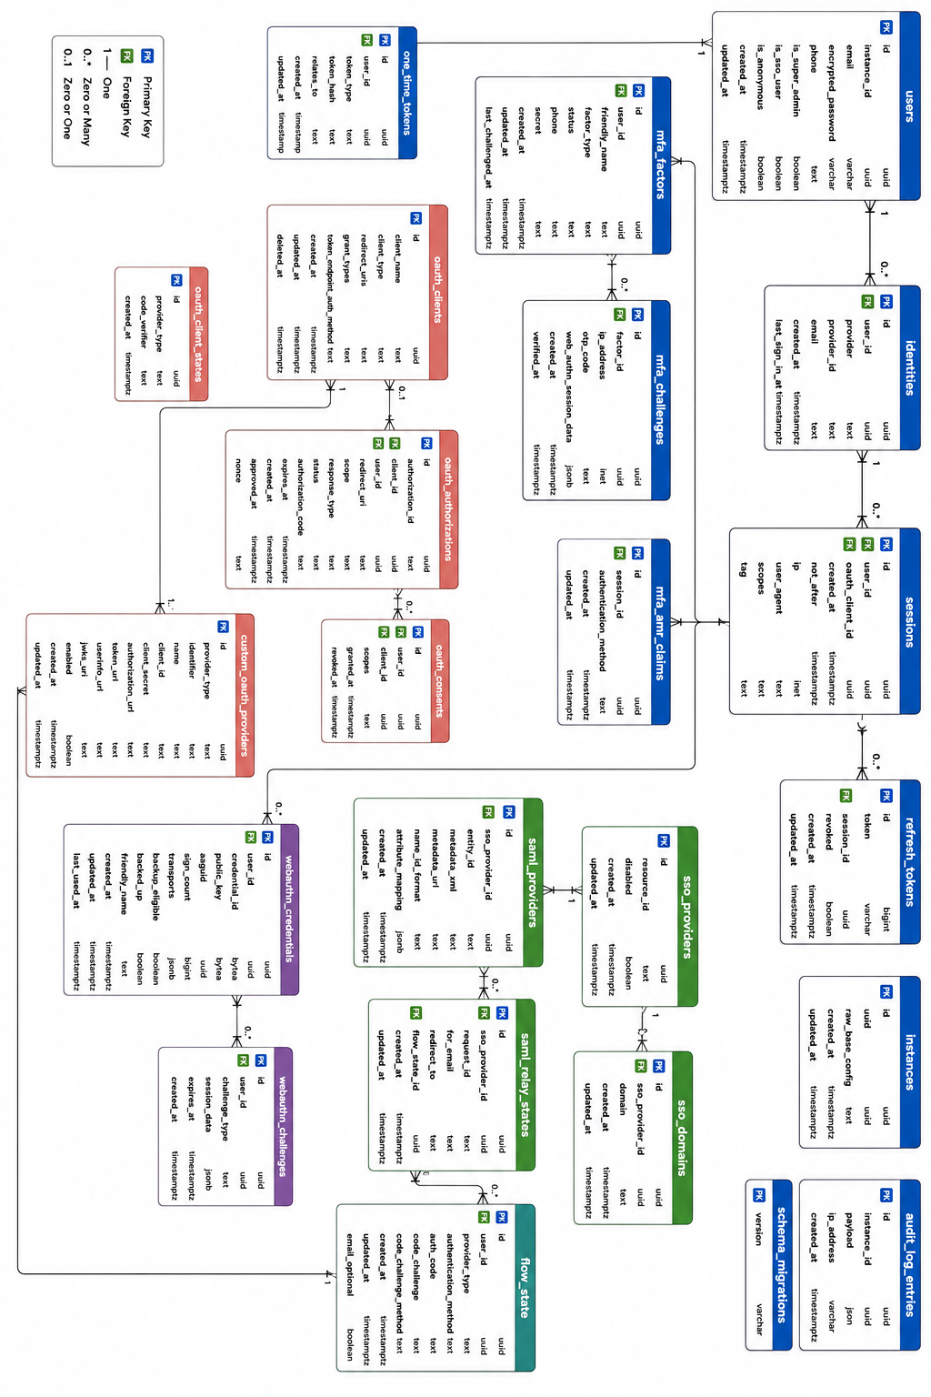
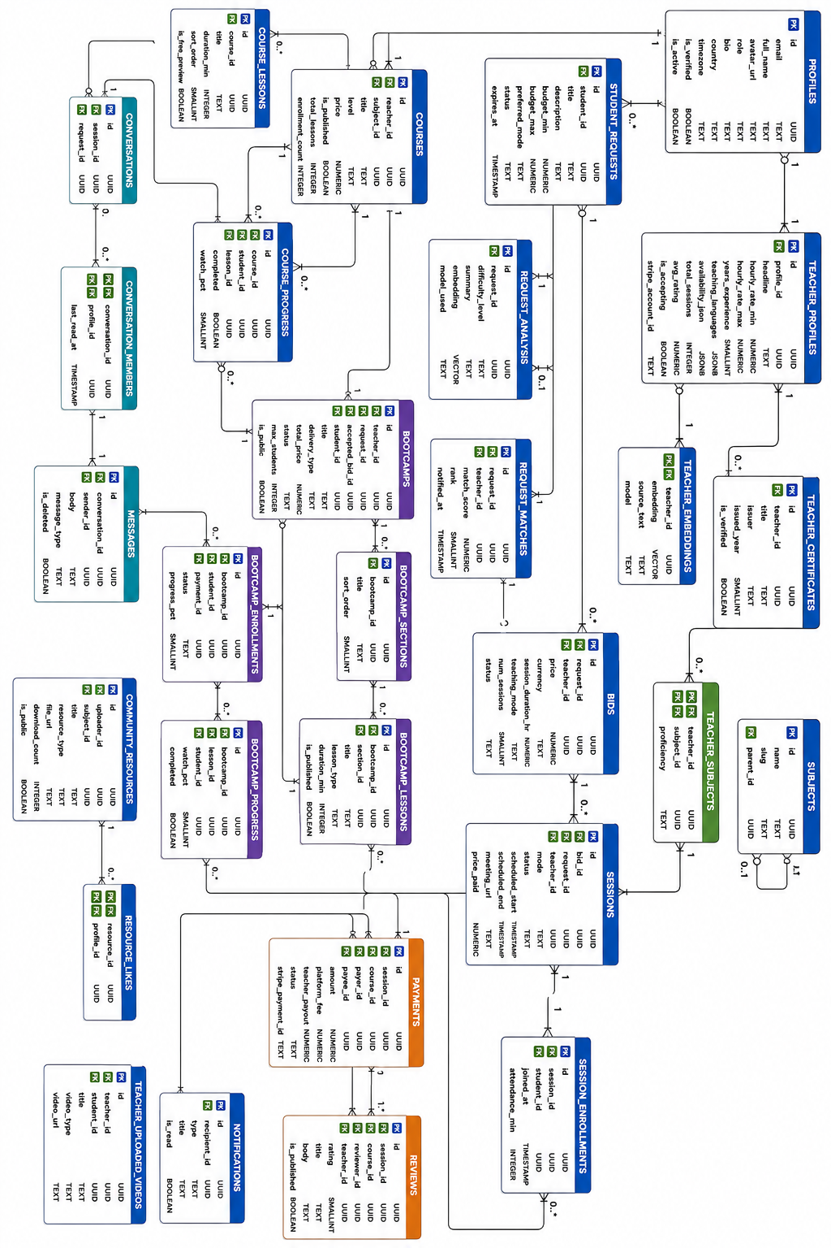

3.3 Data Flow Diagrams

3.3.1 DFD Level 0 (Context Diagram)
The DFD Level 0, also known as the context diagram, represents the Educational AI Platform System as a single high-level process and illustrates its interaction with external entities. This level defines the system boundary and shows how data flows into and out of the system without detailing internal processes. The system interacts with Students, who provide registration data, login credentials, course enrollment requests, uploaded lecture PDFs, assignments submissions, and learning preferences. In return, the system provides personalized course recommendations, AI-based learning assistance, lecture materials, progress tracking, grades, notifications, and study suggestions. Teachers interact with the system by providing course content, uploading lectures, creating assignments, and managing student evaluations. The system responds by giving them student submissions, performance analytics, AI-supported teaching insights, and communication tools. Administrators manage platform operations by providing system configuration, user management actions, and content moderation requests. The system returns dashboards, usage statistics, reports, and control access over platform activities. The system also communicates with External AI Services, which receive student performance data, uploaded lecture content, and queries from users. These services return intelligent outputs such as teacher-student matching, study recommendations, content summarization, and AI chatbot responses.
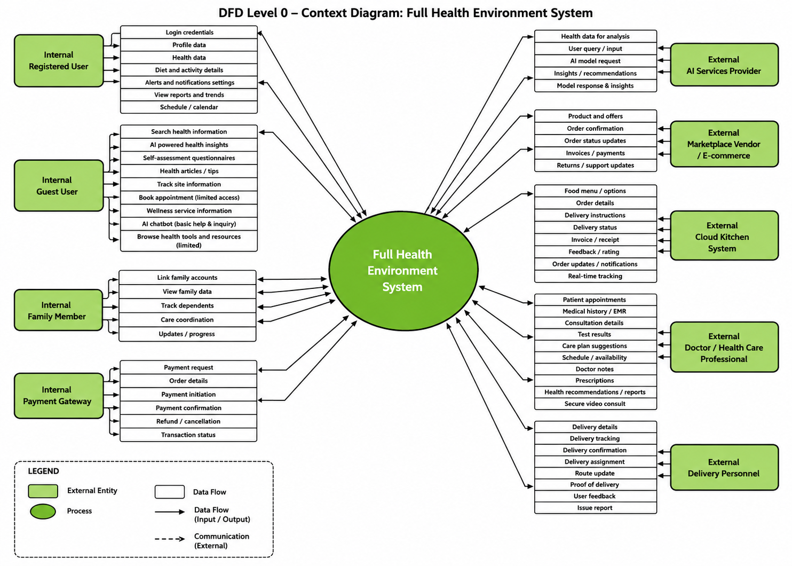
The File Storage / Cloud System receives uploaded PDFs, assignments, and lecture materials, and returns secure file access, retrieval, and storage confirmation. Additionally, the system interacts with a Notification Service, which receives event triggers such as deadlines, new lectures, and assignment updates, and sends back real-time alerts and reminders to users. Overall, the DFD Level 0 demonstrates how the Educational AI Platform acts as a centralized system that connects students, teachers, administrators.

3.3.2 DFD Level 1 — Educational AI Platform
Process 1.0: User & Profile Management
This process manages user registration, authentication, and profile maintenance for both students and teachers. It handles login credentials, personal information, role assignment (student or teacher), and account settings. User data is securely stored in the User Database and shared with other system processes to enable personalized learning services and access control across the platform.
Process 2.0: Course & Content Management
This process is responsible for managing educational content provided by teachers. It handles course creation, lecture uploads, and study materials such as PDFs and videos. Students can browse available courses and enroll in them. All course-related data is stored in the Course Content Database and made accessible based on user permissions and enrollments.
Process 3.0: AI Matching System
This process represents the core intelligence of the system. When a student uploads a PDF or enters a subject of interest, the system sends the input to the AI Matching Service. The AI analyzes the content, extracts key topics, and matches the student with the most suitable teacher based on expertise and subject relevance. The recommendations are returned to the system and stored for future use in the matching history.

Process 4.0: Learning Interaction & Progress Tracking
This process manages the learning activities between students and teachers. It includes assignment submission, course progress monitoring, and performance evaluation. Students interact with course materials while teachers provide feedback and assignments. All learning progress data is stored in the Learning Progress Database for analysis and improvement of the learning experience.
Process 5.0: Payment & Subscription System
This process handles all financial operations within the platform. It manages course payments, subscription plans, and access to premium content. Payment requests are sent to the Payment Gateway for secure processing. After successful payment, access permissions are updated, and transaction records are stored in the Transactions Database.
Process 6.0: Notifications, Rewards & AI Interaction
This process manages system-wide notifications, reminders, rewards, and AI chatbot interactions. It sends alerts related to course updates, assignments, payments, and AI recommendations. The system also supports communication between users and an AI chatbot to assist in learning and platform navigation. All notification data and reward points are stored in the Notifications & Rewards Database.

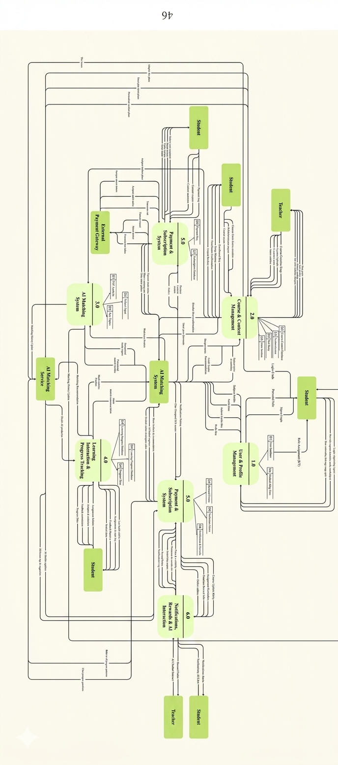

3.4 State Diagram

3.4.1 Authentication State
The system starts in the Unauthenticated state. When the user enters login credentials, the system transitions to Authenticating. If the credentials are valid, the state changes to Authenticated. For first-time users, the system enters Profile Setup Required, where personal information and role selection (Student or Teacher) are completed. After all required information is provided, the system
moves to Profile Completed and grants access to platform services as shown in Figure 3.4.1.

3.4.2 AI Teacher Matching State
The process starts at Matching Idle. When a student uploads a PDF document or enters a subject, the system moves to Receiving Input. The uploaded content is analyzed in Analyzing Content, where keywords and topics are extracted. The system then transitions to Finding Suitable Teachers and compares the extracted topics with teacher expertise profiles. If suitable matches are found, the process reaches Recommendations Ready and stores the results in the matching history. If no match is found, the system enters No Match Found before returning to idle as shown in Figure 3.4.2.

3.4.3 Course Enrollment State
Beginning from Enrollment Idle, the student browses available courses and selects a course. The system enters Enrollment Request Submitted. If the course requires payment, the process transitions to Waiting for Payment. Upon successful payment or approval, the system moves to Enrollment Confirmed and grants access to course materials. If enrollment fails, the system enters Enrollment Rejected before returning to idle as shown in Figure 3.4.3.

3.4.4 Course Content Management State
The process starts in Content Idle. When a teacher creates a new course or uploads learning materials, the system transitions to Uploading Content. The uploaded files are validated in Validating Content. If validation succeeds, the system moves to Content Published and stores the materials in the course database. If validation fails, the process enters Content Upload Failed and returns to idle after correction as shown in Figure 3.4.4.

3.4.5 Assignment Submission State
The workflow begins in Assignment Idle. When a student submits an assignment, the system transitions to Submitting Assignment. The uploaded file is checked in Validating Submission. If valid, the state becomes Submission Stored and the teacher is notified. Once the teacher reviews the work, the process reaches Grade Assigned and updates the student's learning progress. Invalid submissions lead to Submission Rejected before returning to idle as shown in Figure 3.4.5

3.4.6 Learning Progress Tracking State
Starting from Progress Idle, the system monitors student activity while courses are being studied. As students complete lessons, quizzes, or assignments, the system moves to Updating Progress. The progress data is analyzed and stored in Progress Recorded. Once updates are completed, dashboards and reports are refreshed in Progress Updated before returning to idle as shown in Figure 3.4.6.

3.4.7 Payment & Subscription State
The process starts at Payment Idle. When a student chooses a paid course or subscription plan, the system enters Creating Payment Request. The request is sent to the payment gateway in Processing Payment. If payment succeeds, the system transitions to Payment Successful, updates access permissions, and stores transaction details. Failed transactions move the system to Payment Failed before returning to idle as shown in Figure 3.4.7.

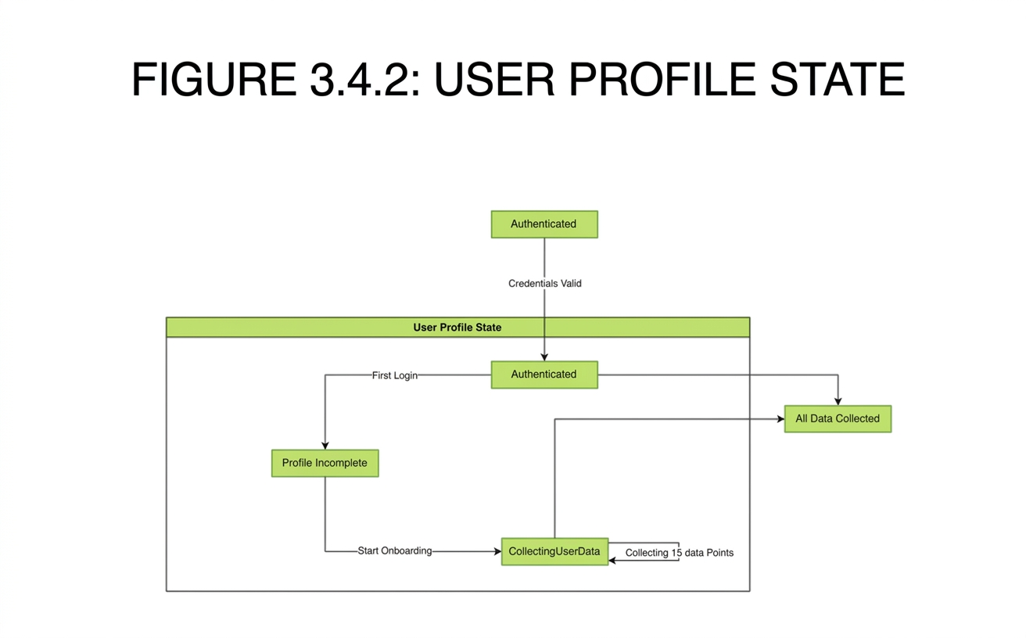
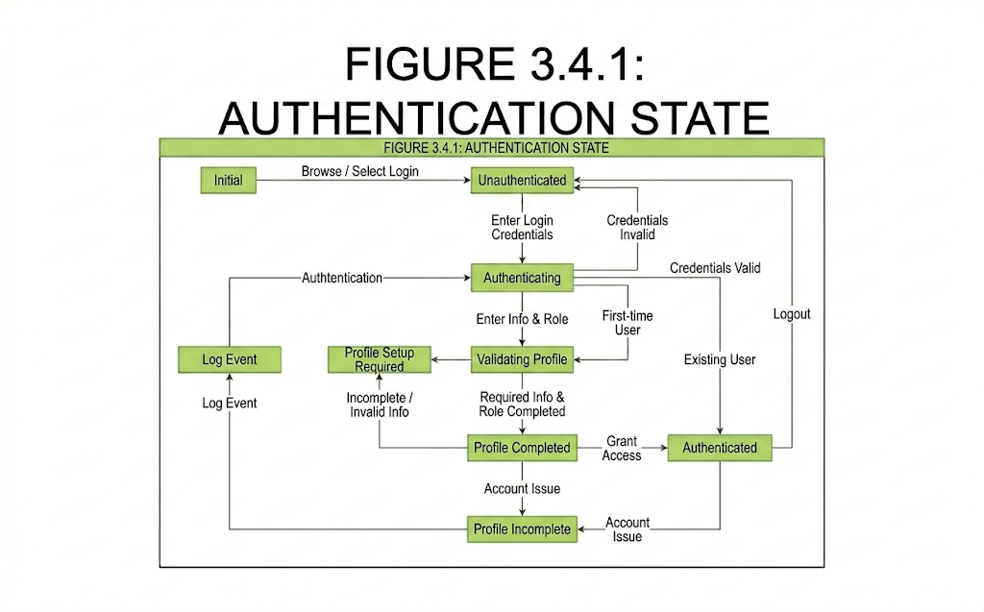

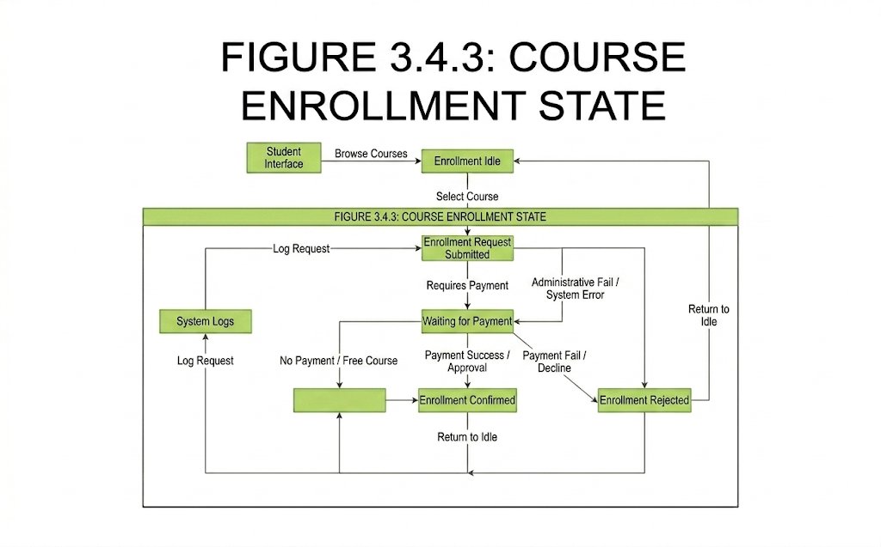
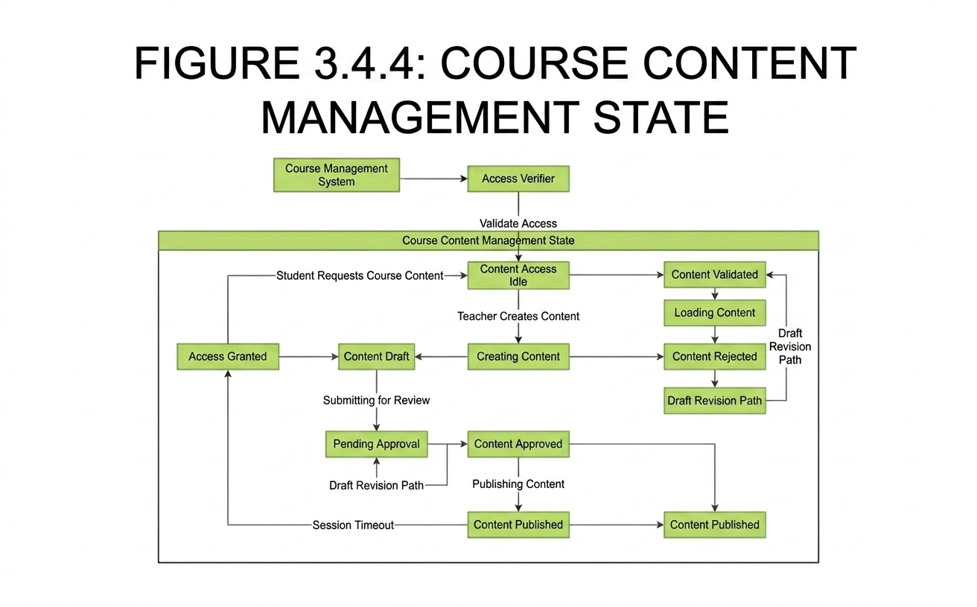
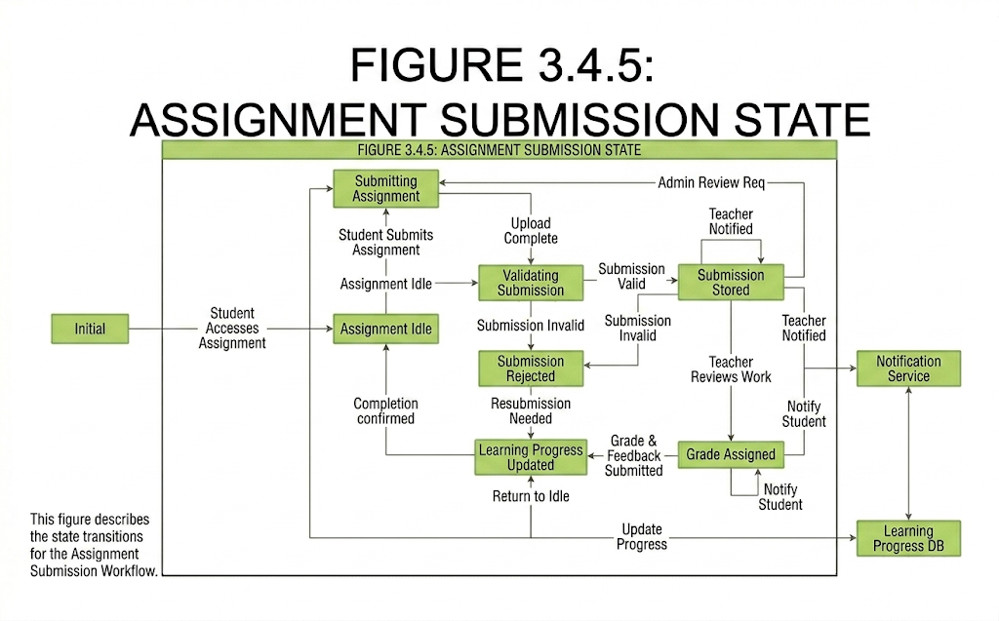
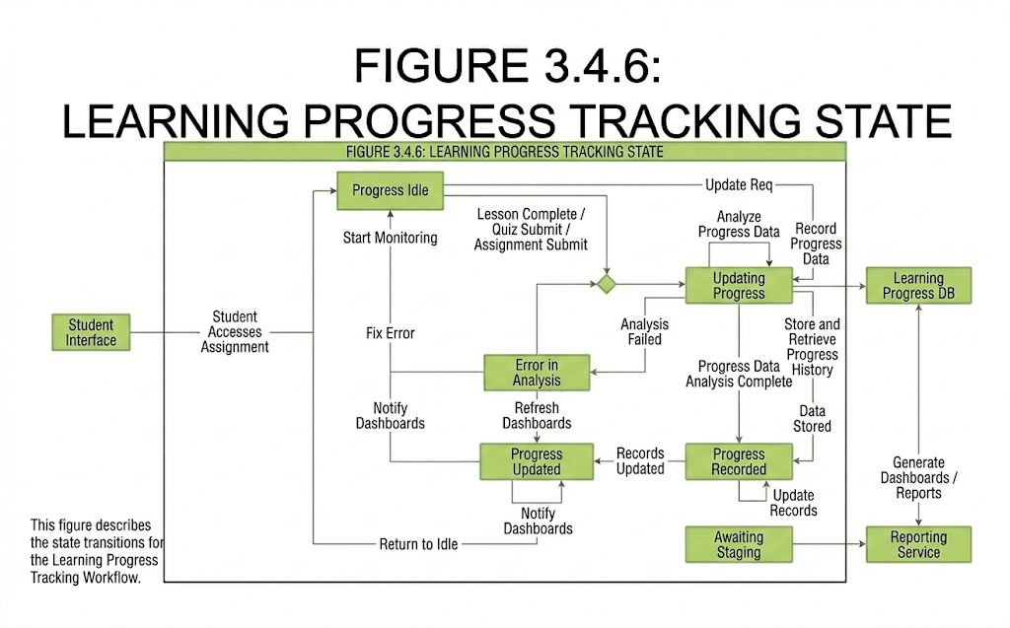
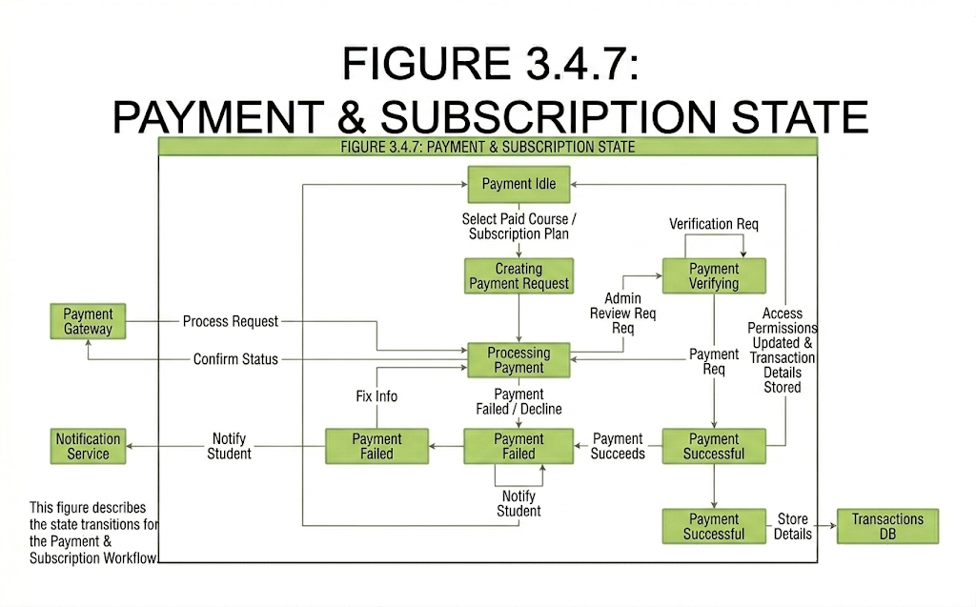
3.5 UML Diagram
The UML Class Diagram represents the static structure of the Educational Platform and illustrates the main classes, attributes, methods, and relationships between system components. The diagram provides a detailed view of how students, teachers, courses, AI services, and platform management modules interact to support the learning process.
User Class
The User class serves as the parent class for all system users. It contains common attributes such as userID, name, email, password, and role. It also includes operations related to authentication and profile management.
Student Class
The Student class inherits from the User class and represents learners using the platform. Students can enroll in courses, upload PDF documents for AI analysis, submit assignments, and communicate with teachers.
Teacher Class
The Teacher class inherits from the User class and represents instructors on the platform. Teachers can create courses, upload learning materials, manage assignments, and evaluate student performance.
Course Class
The Course class stores information related to educational courses, including course title, description, category, and price. Each course is managed by a teacher and can contain multiple learning materials and assignments.
Enrollment Class
The Enrollment class manages the many-to-many relationship between students and courses. It stores enrollment information such as enrollment date, completion status, and progress percentage.
CourseMaterial Class
The CourseMaterial class represents educational resources uploaded by teachers, including PDF files, presentations, videos, and other study materials.
Assignment Class
The Assignment class manages course assignments. Teachers create assignments and students submit solutions before deadlines.
AssignmentSubmission Class
The AssignmentSubmission class stores student submissions, grades, feedback, and submission dates.
AIMatching Class
The AIMatching class represents the intelligent recommendation system. It analyzes uploaded PDFs or selected subjects and matches students with suitable teachers according to expertise and course relevance.
Payment Class
The Payment class handles financial transactions within the platform, including course purchases and subscription payments.
Subscription Class
The Subscription class manages premium access plans and stores subscription details such as plan type, activation date, and expiration date.
Notification Class
The Notification class manages alerts, reminders, course updates, and system messages sent to users.

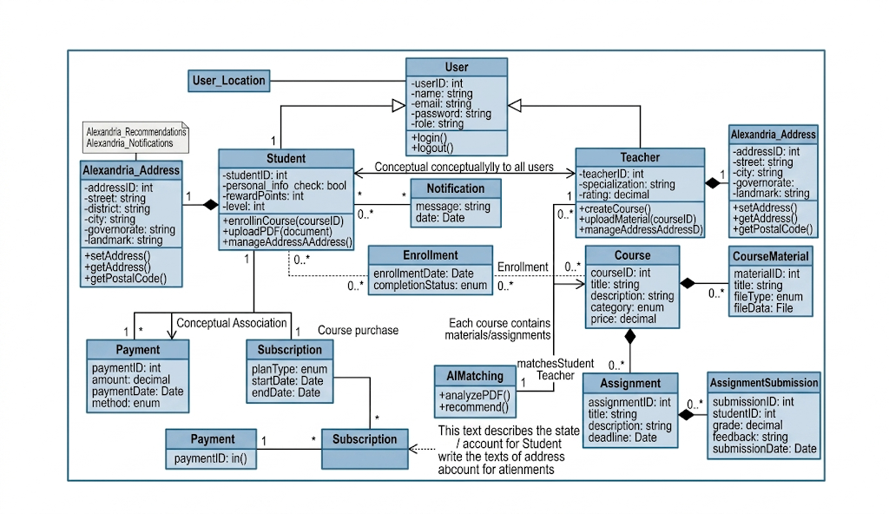

Chapter 4 ( Implementation Aspect)

4.1 Overall System Architecture (Block Diagram)
The Overall System Architecture illustrates the main components of the Educational Platform and the interactions between them. The architecture follows a multi-layered design that separates the user interface, business logic, artificial intelligence services, and data storage components. This separation improves system scalability, maintainability, security, and performance.
The system supports two primary user types: Students and Teachers. Both users access the platform through a Web or Mobile Application, which serves as the presentation layer and provides access to all system functionalities.
The application communicates with the Backend API Layer, which acts as the central controller of the system. This layer processes requests, manages business logic, validates user actions, and coordinates communication between internal services and external systems.
The User Management Module is responsible for registration, authentication, profile management, and role assignment. It ensures secure access to the platform and manages user-related information.
The Course Management Module handles course creation, course enrollment, lecture uploads, educational materials, and assignment management. Teachers can create and publish courses, while students can browse and enroll in available courses.
The AI Matching Module represents the intelligent core of the platform. When students upload PDF documents or specify learning interests, the AI engine analyzes the content, extracts relevant topics, and recommends suitable teachers based on expertise, qualifications, and subject relevance.
The Learning Progress Module monitors student activities, assignment submissions, grades, and course completion rates. It provides performance tracking and supports personalized learning experiences.
The Payment and Subscription Module manages financial transactions, subscription plans, premium content access, and payment verification through secure payment gateways.
The Notification and Communication Module handles system notifications, assignment reminders, course updates, and AI-generated recommendations. It also supports communication between users and the AI chatbot assistant.
All system modules interact with the central Database Layer, which stores user accounts, courses, learning materials, enrollments, assignment records, AI matching history, subscriptions, payments, and notifications. Uploaded PDF documents and multimedia content are stored in the File Storage System, which ensures efficient management of large educational resources.
The architecture is designed to support future expansion, allowing additional AI services, learning analytics features, and advanced recommendation algorithms to be integrated without affecting existing system functionality.
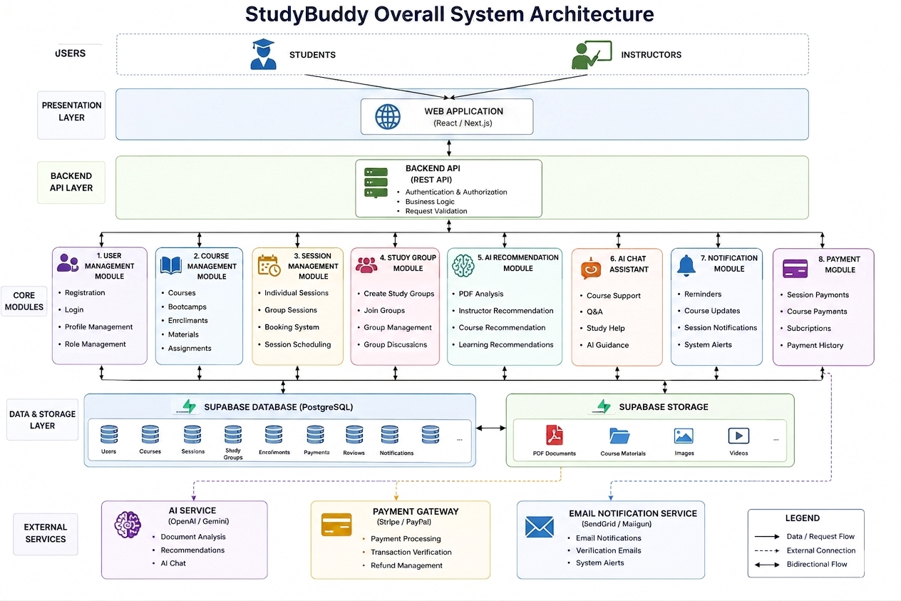

4.2 Tools, Technologies and Programming Languages Used
The StudyBuddy platform is developed using modern web technologies, cloud services, and Artificial Intelligence solutions to provide a scalable, secure, and intelligent learning environment. The following tools and technologies are utilized within the system architecture shown in Figure 5.1.
Frontend Technologies
- HTML5 – Structure and content of web pages.
- CSS3 – User interface styling and responsive design.
- JavaScript – Client-side functionality and interactivity.
- React.js – Building dynamic and reusable user interface components.
Backend Technologies
- Node.js – Server-side runtime environment.
- Express.js – RESTful API development and request handling.
Database & Storage
- Supabase PostgreSQL – Main relational database used for storing users, courses, sessions, enrollments, reviews, and payments.
- Supabase Storage – Storage of PDF documents, educational materials, and uploaded files.
- Artificial Intelligence Technologies
- AI Model – Used for PDF analysis, lecture explanation, educational assistance, question answering, content summarization, and instructor recommendation.
- AI Recommendation System – Matches students with suitable instructors based on uploaded materials, academic interests, and learning requirements.
- AI Recommendation and PDF Analysis Workflow
- The AI module is responsible for analyzing uploaded lecture materials and recommending suitable instructors. The workflow consists of the following steps:
- The student uploads a PDF document through the platform.
- The system extracts textual content from the uploaded PDF.
- The AI model analyzes the extracted text and identifies the main topics, keywords, and academic subjects.
- Instructor profiles stored in the database contain information about specializations, expertise, and teaching subjects.
- The recommendation engine compares the extracted topics with instructor specializations and calculates a relevance score for each instructor.
- Instructors are ranked according to their relevance scores.
- The system returns the top recommended instructors to the student.
- The AI module can also generate summaries, explanations, and educational assistance based on the uploaded materials.
- This workflow enables personalized learning support and improves the accuracy of student–instructor matching within the StudyBuddy platform.

Authentication & Security
- Supabase Authentication – User registration, login, and role-based access control.
- JWT (JSON Web Token) – Secure authentication and session management.
Development Tools
- Visual Studio Code (VS Code) – Source code editor and development environment.
- Git – Version control system.
- GitHub – Source code hosting and team collaboration.

Design & Modeling Tools
- Figma – UI/UX design and prototyping.
- Draw.io – ERD, UML diagrams, and system architecture diagrams.

Deployment & Hosting
- Vercel – Frontend deployment and hosting.
- Supabase Cloud Platform – Database, authentication, and storage hosting.

4.3 Prototype

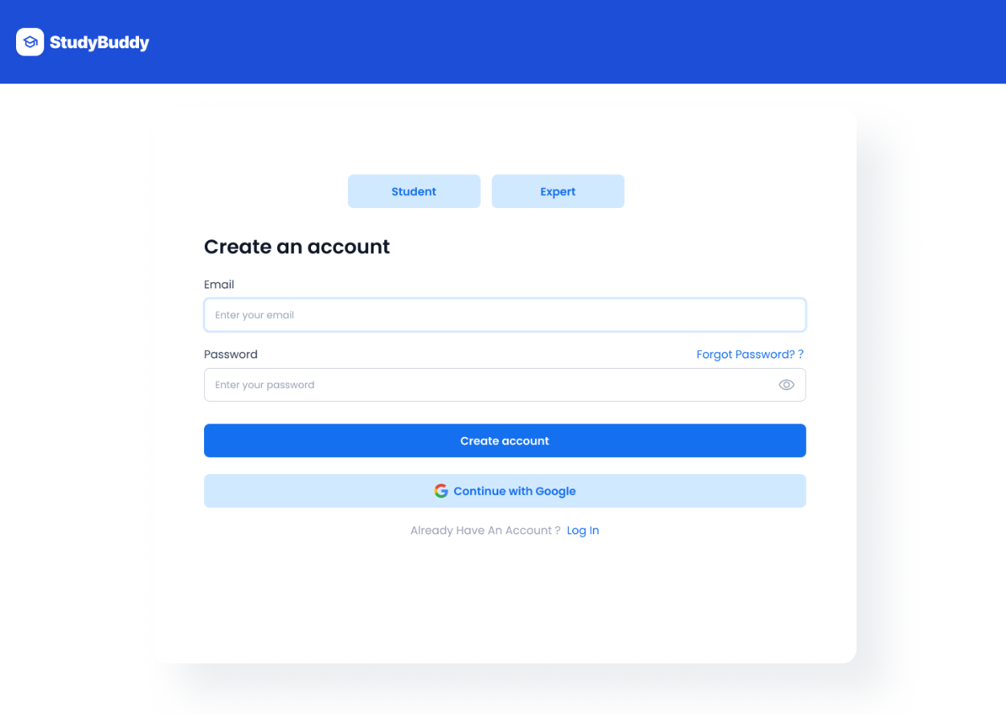
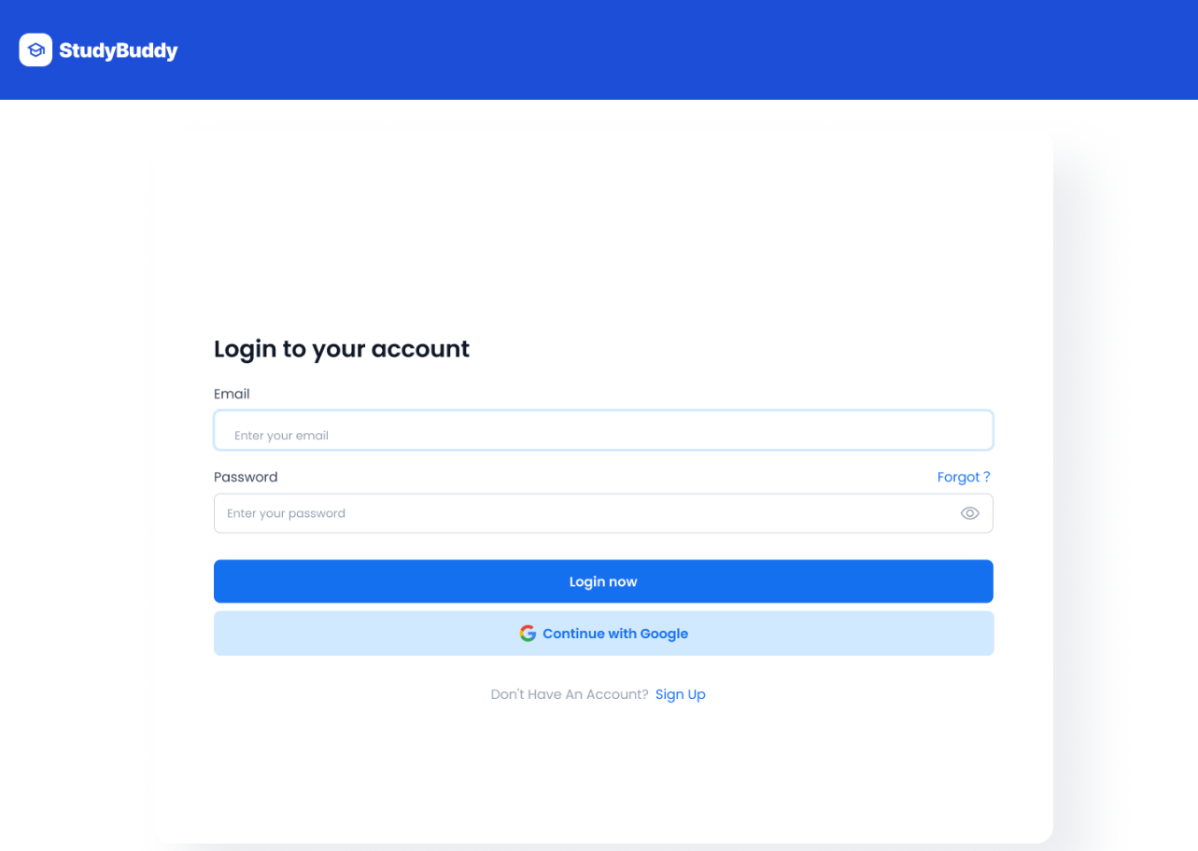
Figure 4.3.1: Login & Registration Page

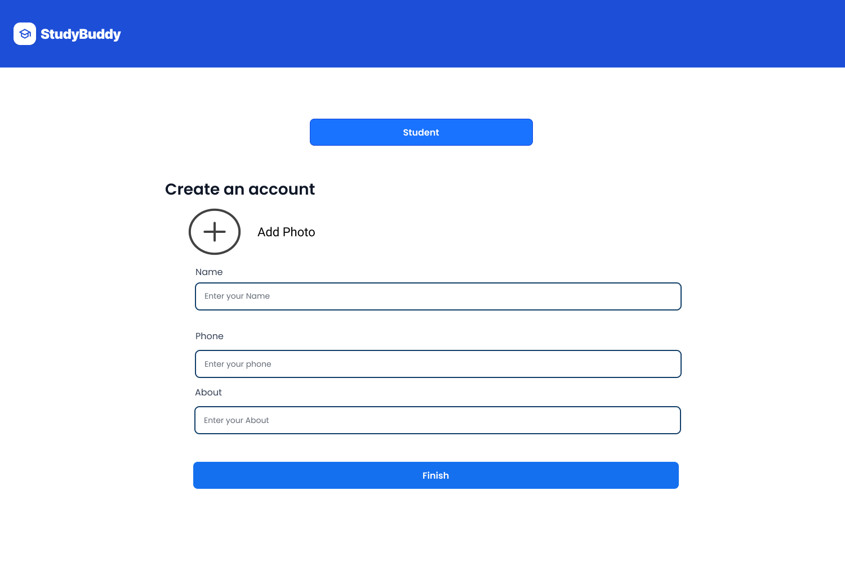
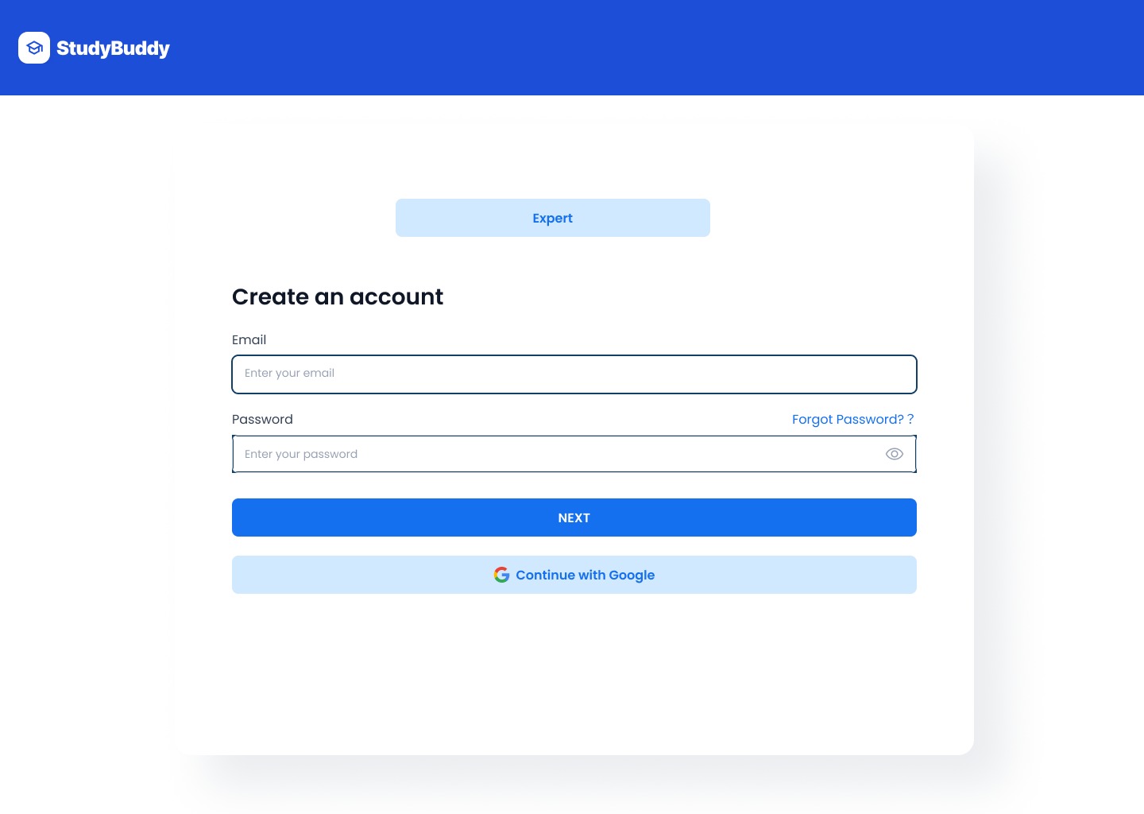

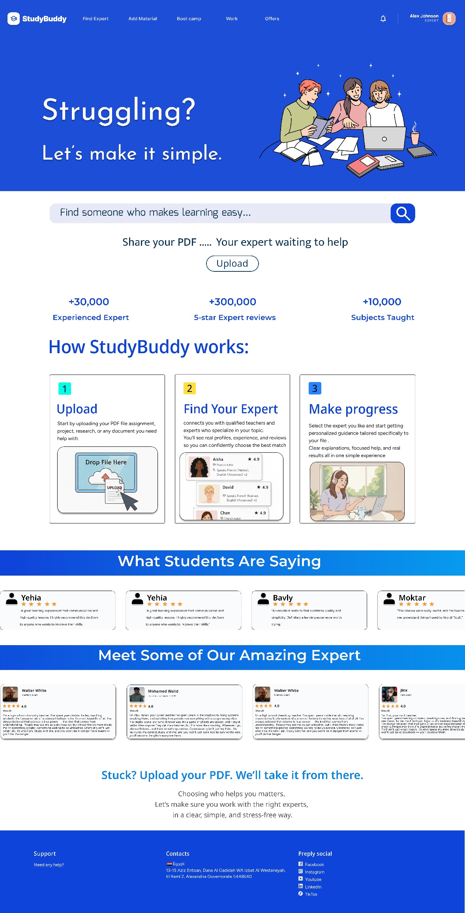
Figure 4.3.2: Home Page

Figure 4.3.3: Add Material
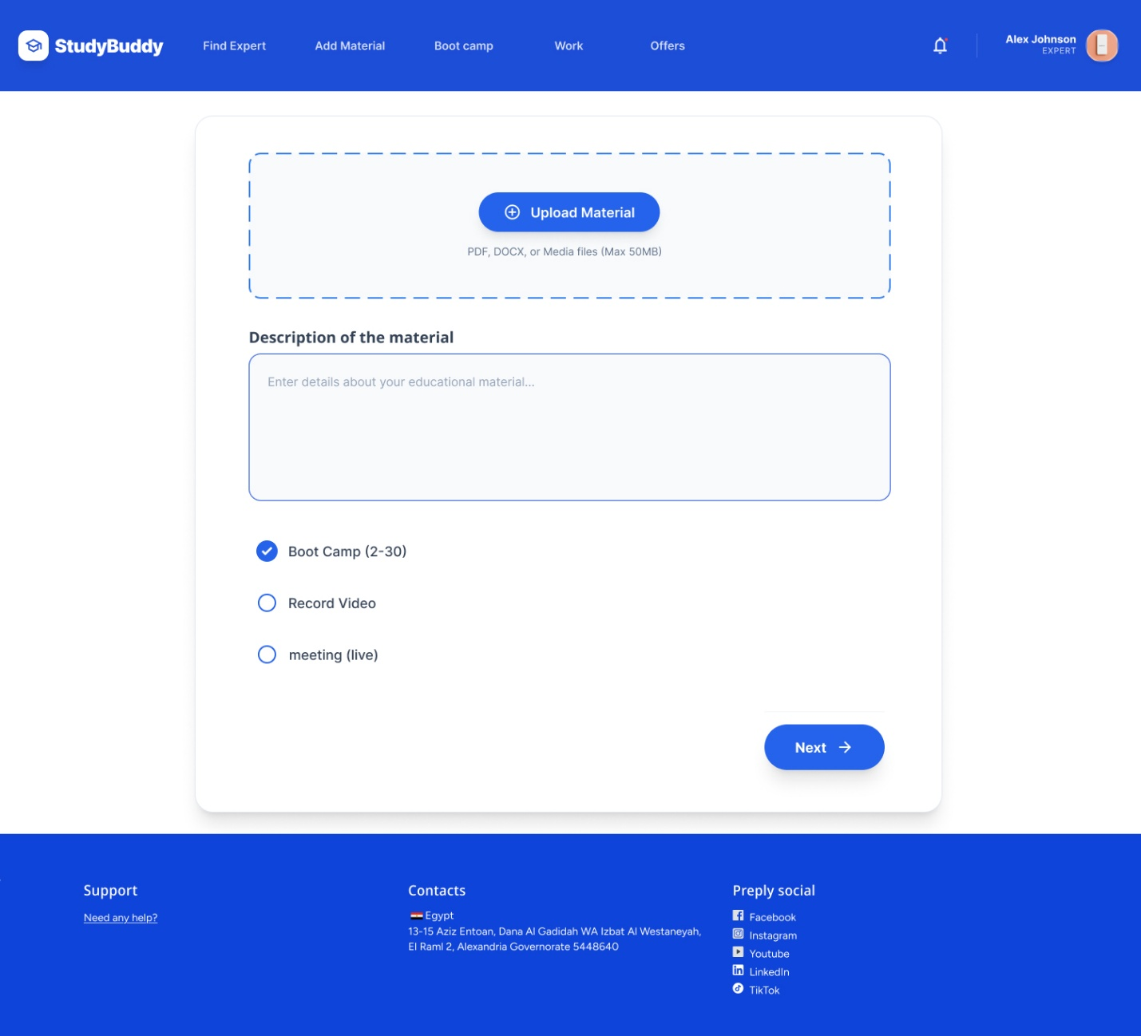

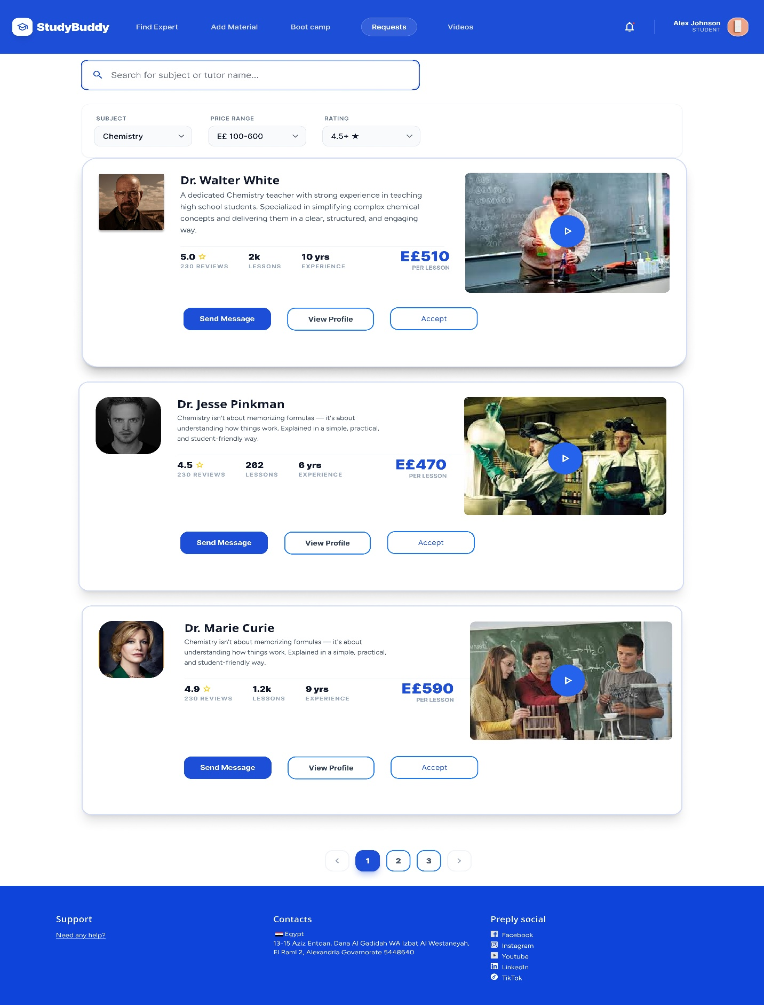
Figure 4.3.4: Offer Page

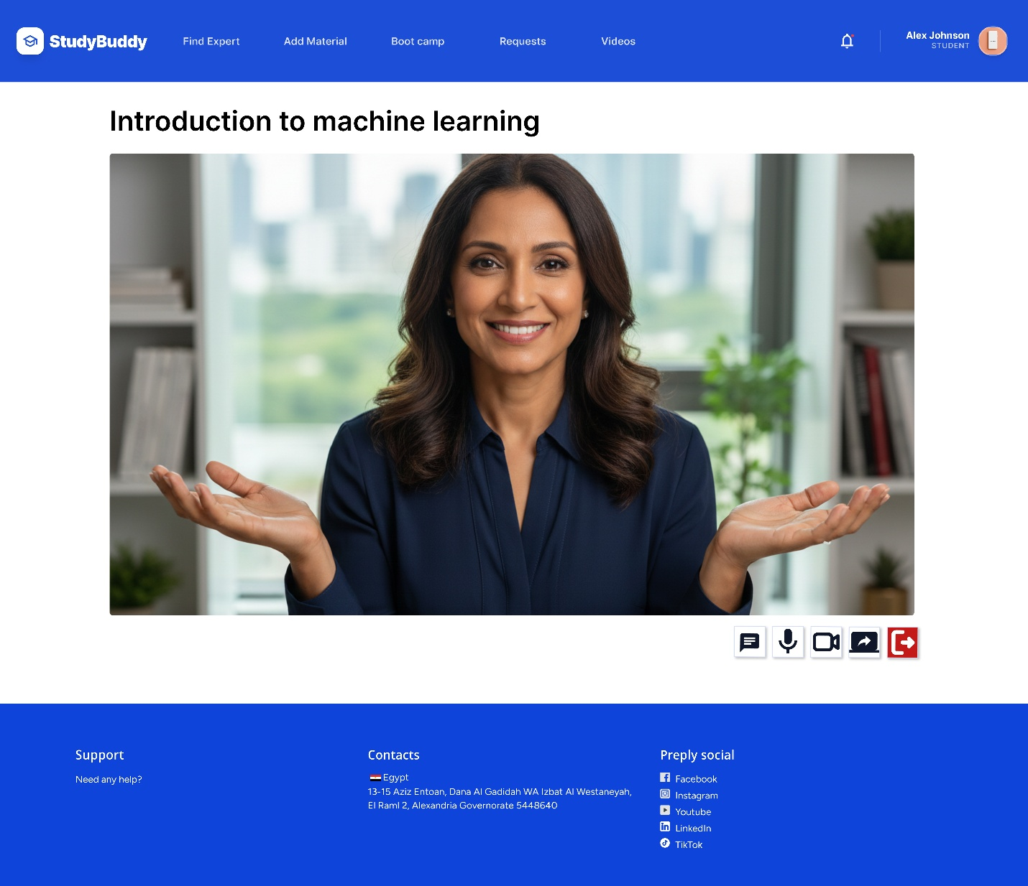
Figure 4.3.5: Session

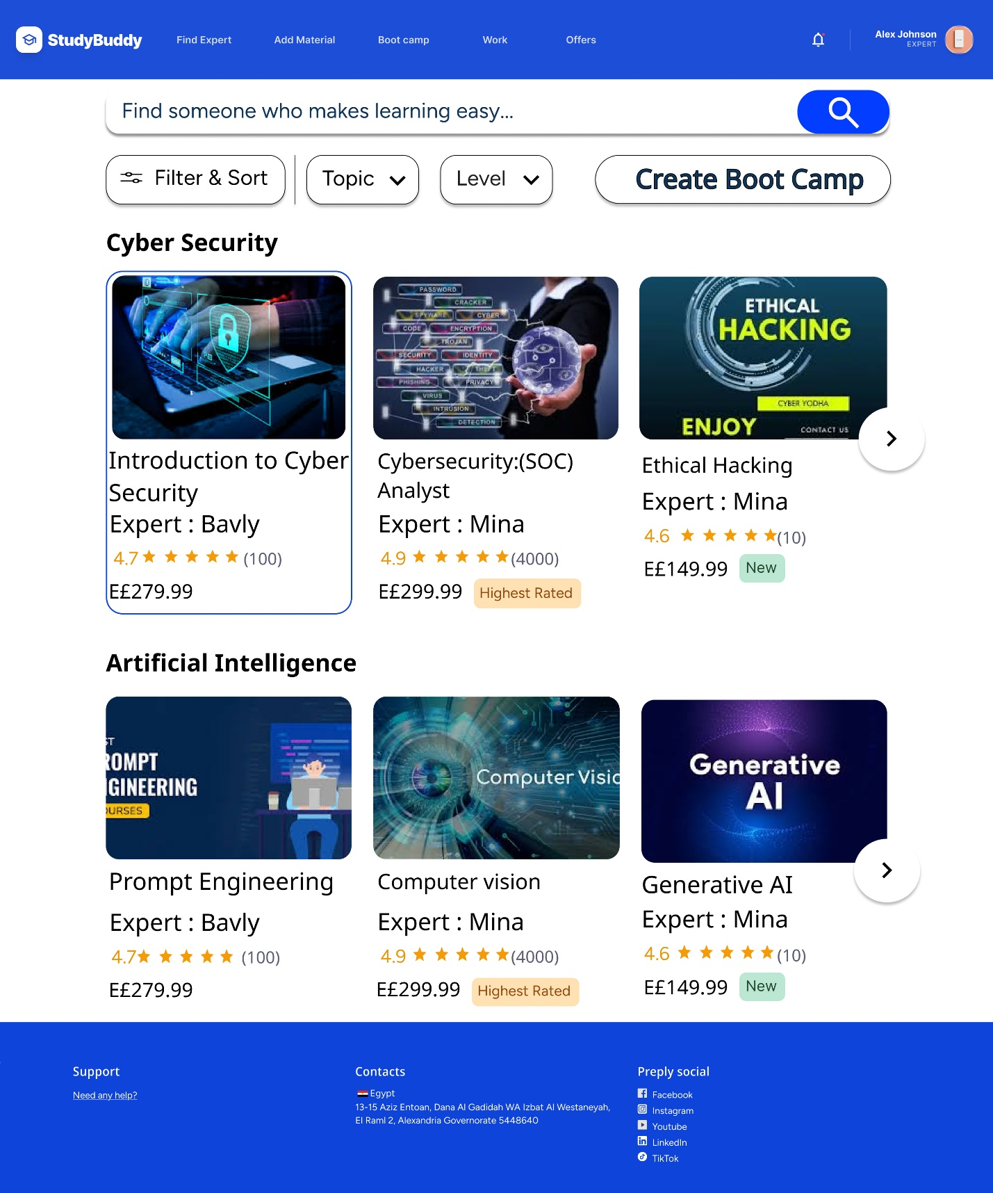
Figure 4.3.6: Bootcamp


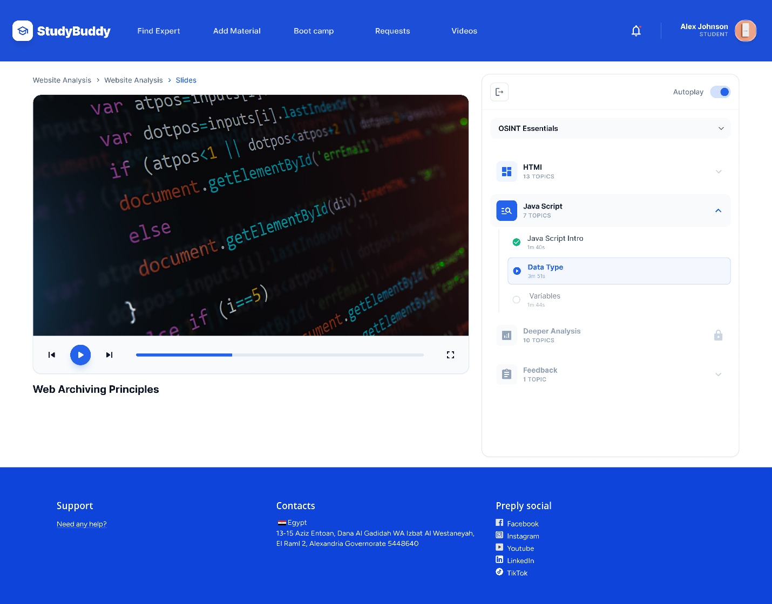
Figure 4.3.7: bootcamp video

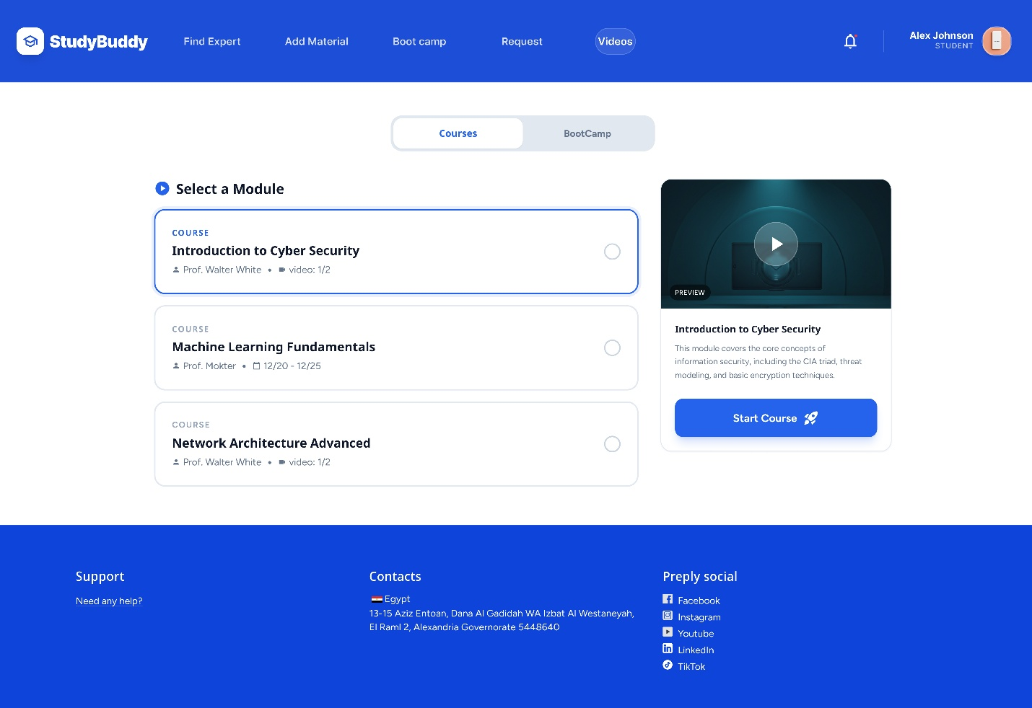
Figure 4.3.8: course

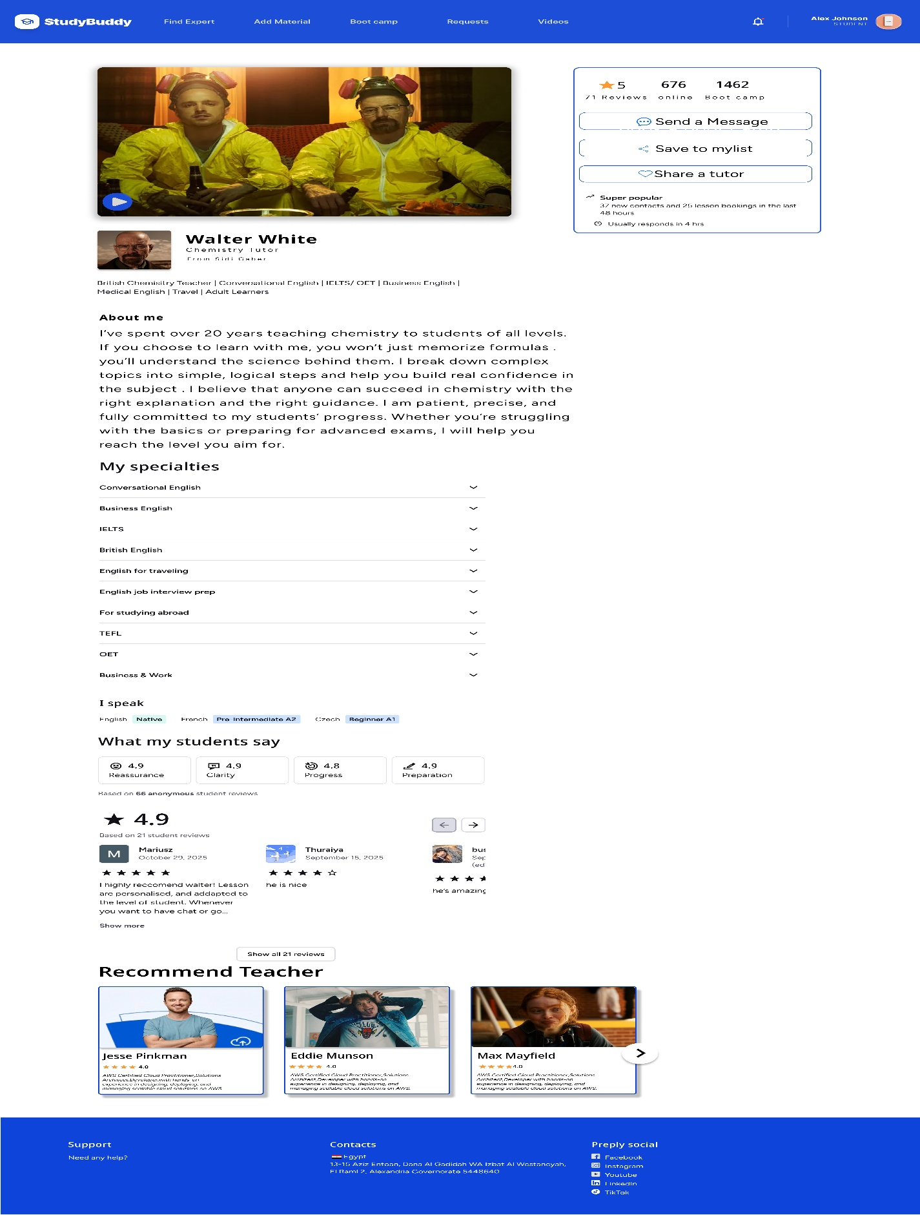
Figure 4.3.9: Instructor Profile Page

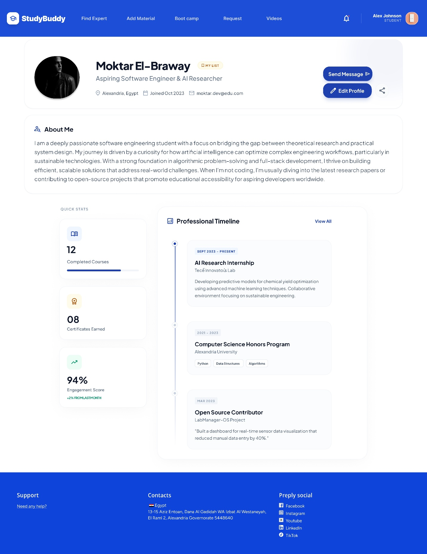
Figure 4.3.10: Students profile

Figure 4.3.11: Payment Page
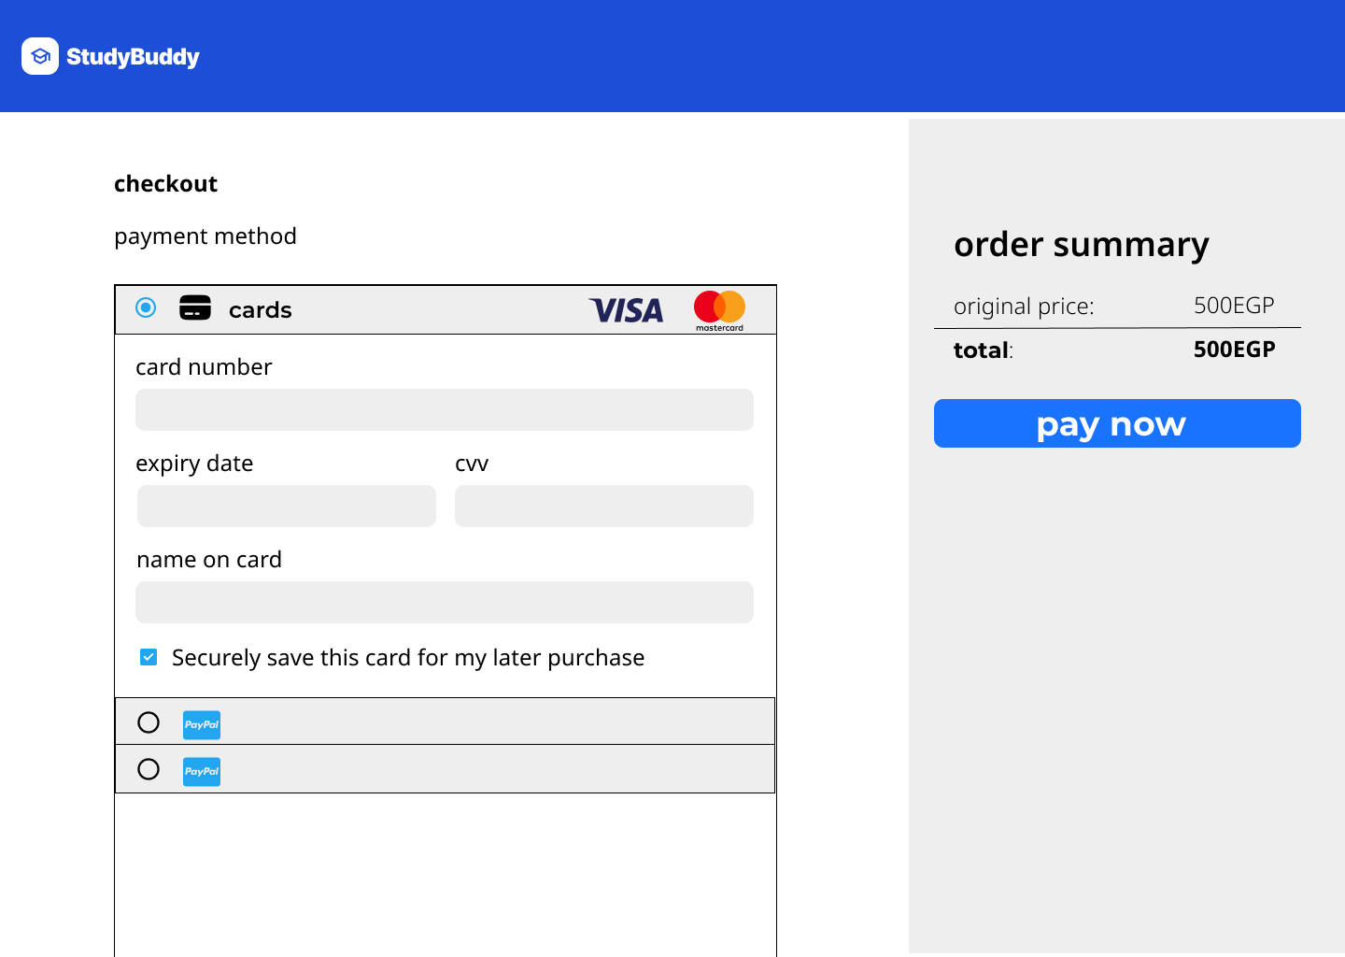

Figure 4.3.12: Favorite


Figure 4.3.13: support

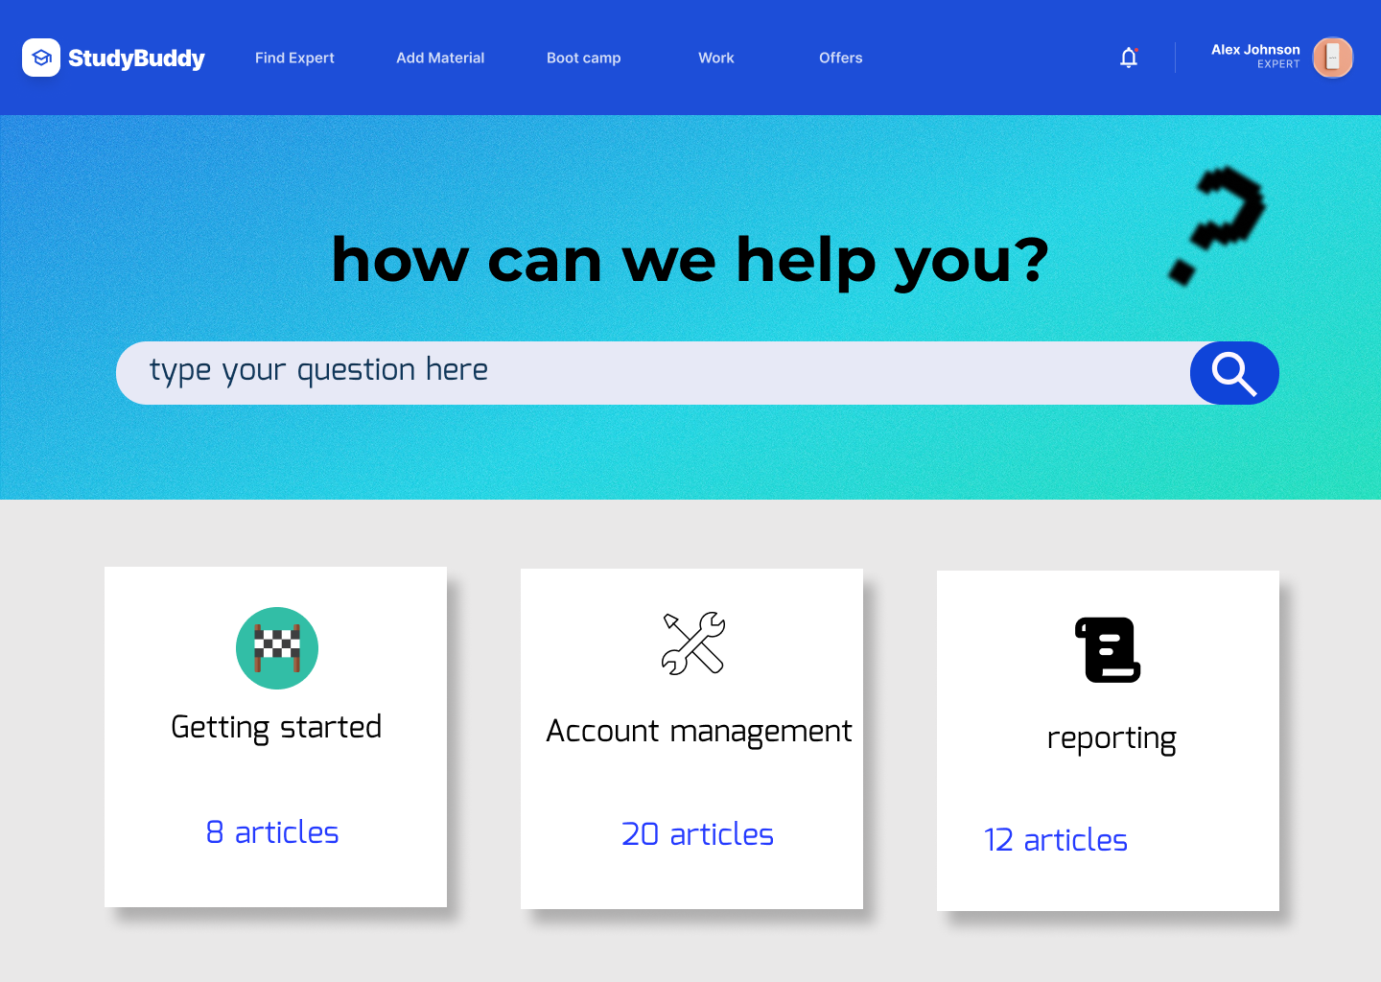

4.4 References
- React Documentation. Available: https://react.dev
- Node.js Documentation. Available: https://nodejs.org/docs
- Express.js Documentation. Available: https://expressjs.com
- Supabase Documentation. Available: https://supabase.com/docs
- OpenAI API Documentation. Available: https://platform.openai.com/docs
- PostgreSQL Documentation. Available: https://www.postgresql.org/docs
- GitHub Documentation. Available: https://docs.github.com
- Figma Documentation. Available: https://help.figma.com
- Draw.io Documentation. Available: https://www.diagrams.net
- JWT Documentation. Available: https://jwt.io/introduction
- Preply Platform. Available: https://preply.com
- StudyBay Platform. Available: https://studybay.com
- StudyLoop Platform. Available: https://studyloop.com
- Vercel Documentation. Available: https://vercel.com/docs

4.5 Conclusion
StudyBuddy is an educational platform designed to connect university students with qualified instructors in a simple and efficient way. The platform aims to help students better understand their courses through individual and group learning sessions, study groups, courses, bootcamps, and AI-powered educational support.
The system provides a smart learning environment where students can upload educational materials, receive AI-generated explanations, and find suitable instructors based on their academic needs. At the same time, instructors can expand their reach, offer educational services, and connect with students who need support in specific subjects.
By combining modern web technologies, cloud services, and Artificial Intelligence, StudyBuddy offers a scalable and user-friendly solution that improves communication between students and instructors while making learning more accessible, collaborative, and affordable.
In the future, the platform can be enhanced with additional AI features, learning analytics, and advanced recommendation systems to further improve the educational experience.

4.6 Future Work
Although StudyBuddy provides an effective solution for connecting university students with qualified instructors, several enhancements can be implemented in future versions to expand the platform’s capabilities and impact.
Future developments may include:
- Developing dedicated mobile applications for Android and iOS devices.
- Integrating an advanced AI chatbot to provide personalized academic assistance and learning support.
- Generating personalized learning paths based on students’ academic level, interests, and progress.
- Providing AI-generated quizzes, assignments, and practice exams from uploaded course materials.
- Implementing an online examination and certification system for courses and bootcamps.
- Expanding the platform to serve all educational stages, including primary, preparatory, secondary, university, and professional education.
- Integrating with universities and educational institutions to support official courses and academic activities.
- Providing internship opportunities, career guidance, and job-related training programs for students.
- Establishing both online and offline learning centers to offer tutoring sessions, workshops, and bootcamps.
- Expanding the platform to multiple countries and supporting different educational systems and languages.
- Creating a comprehensive educational ecosystem that connects students, instructors, educational institutions, training centers, and employers within a single platform.
- Ultimately, StudyBuddy aims to evolve from a student–instructor matching platform into a complete educational ecosystem that supports learning, training, certification, and career development throughout the learner’s educational journey.

